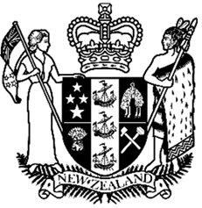
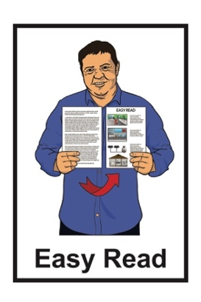

Abuse in care public apology:
Survivor statement by
Fa’afete Taito
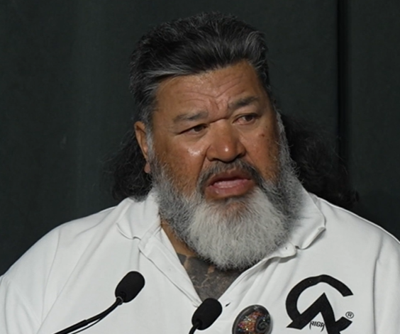

Published: January 2025

Before you start


This Easy Read document talks about abuse.

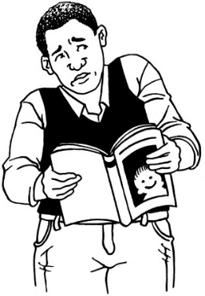

This information may upset some people when they are reading it.

This information is not meant to scare anyone.

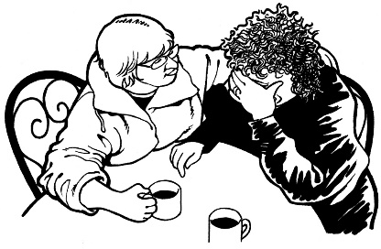
If you are upset after reading this Easy Read document you can talk to your:
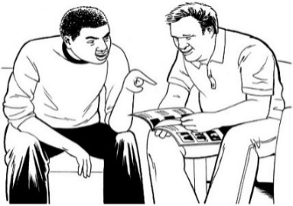
- whānau / family
- friends.


For more support you can contact a helpline called Safe to talk.

You can contact Safe to talk by:

Phone: 0800 044 334

Text: 4334


Email: support@safetotalk.nz

Website: www.safetotalk.nz

Safe to talk is open 24 / 7.



24 / 7 means you can call these helplines any time:

- 24 hours a day which means at any time in the day or night
- 7 days a week.

You can also contact the Survivor Experiences Service to share your experiences of abuse in:
- State care
- faith-based care
- other forms of care.
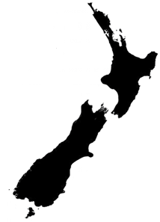

In New Zealand you can:

Phone: 0800 456 090
Text: 8328

Email:

contact@survivorexperiences.govt.nz

It does not cost any money to
call / text the Survivor Experiences Service.

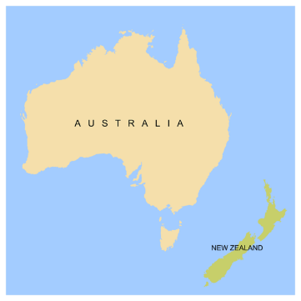
If you are calling from Australia you can phone:

1 800 456 032



You can call this number:


between 8:30 am and 4:30 pm
from Monday to Friday.



These times are for the New Zealand time zones.

You can also send a text to the Survivor Experiences Service on:

+61 438 384 957

It does not cost any money to
call / text the Survivor Experiences Service.

About this document




On 12 November 2024 different parts of the Government made a public apology to people who had been abused while in:
- state / government care
- faith-based care.


Sorry

A public apology is when someone says sorry to a group of people in a way that means everyone can be a part of what is said.

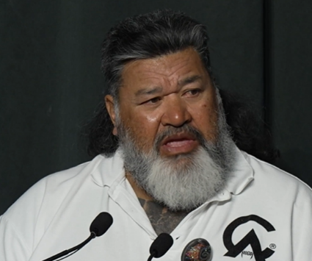
This Easy Read is a summary of the statement Fa’afete Taito made in Parliament before the public apology.


A summary:
- is shorter than the original
message
- tells you what you need to know.


Fa’afete Taito is a survivor.

Survivors are people who have
been through abuse in care.
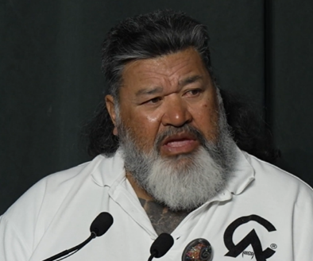

This document includes some quotes from Fa’afete Taito.

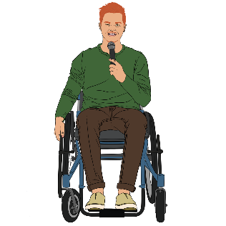
A quote is an exact copy in writing
of what someone has said.
“Hello”

The quotes are in yellow boxes like this.
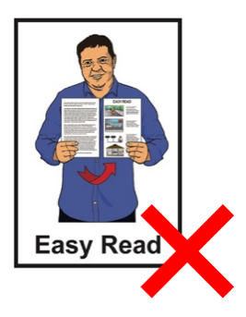
The quotes are not in Easy Read.


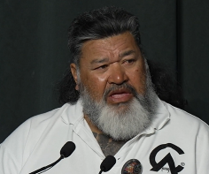
The full speech by Fa’afete Taito is in other formats including:
video
Braille

Large Print.


You can find these versions of the full speech at this website:

https://bit.ly/4jbBcBV

The statement by Fa’afete Taito

Fa’afete Taito said:

“Malo lava le soifua ma le lagi e mama – Tēnā tātou katoa – Greetings.

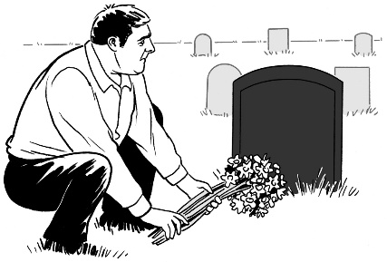
First of all I want to acknowledge again those survivors who have left us to join their ancestors. Rest easy.
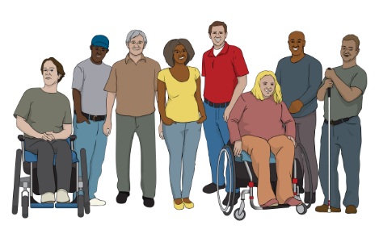
Moe mai rā I want to acknowledge all the survivors in this room, those listening in from the connecting events in Tamaki Makarau, Ōtautahi and here in Whanganui-A-Tara.”


To acknowledge someone means
to say that you know they are there.

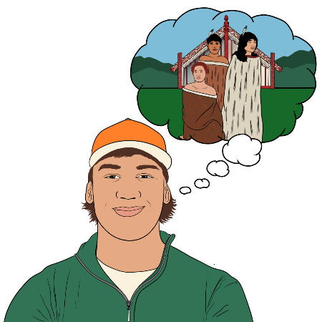
Ancestors are people who:
are part of your whānau / family
were born before you
have died.

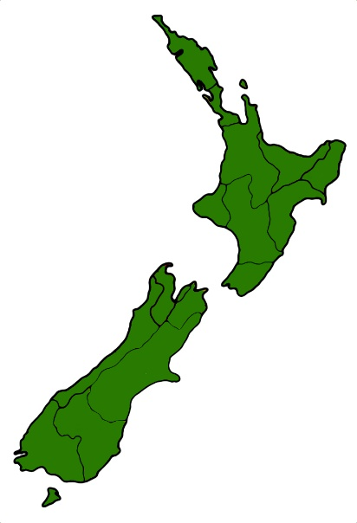
Tamaki Makarau is the te reo Māori name for Auckland.

Ōtautahi is the te reo Māori name for Christchurch.

Whanganui-A-Tara is the te reo Māori name for Wellington.


“I would also like to mihi to the NZ Collective of Abused in State Care also known as NZ CAST for organizing a survivor lead event at Pipitea marae as an alternative venue for watching this historical moment in time and for all the essential support and mahi they continue to provide.”

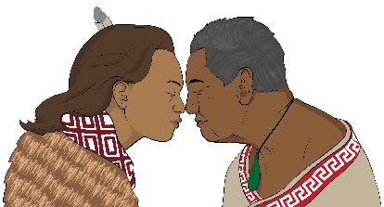
Mihi means to acknowledge someone in te reo.

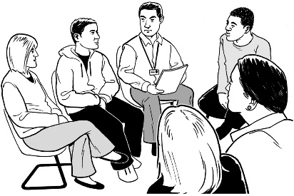
NZ Collective of Abused in State Care / CAST is a group that supports survivors.


An alternative venue means somewhere to watch the apology from that is not at Parliament.

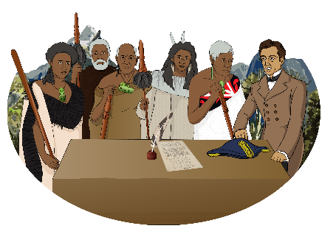
A historical moment in time is something that:
has happened

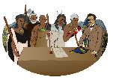
is very important
will be remembered for a long time.


Essential means very needed.

Mahi means work in te reo Māori.

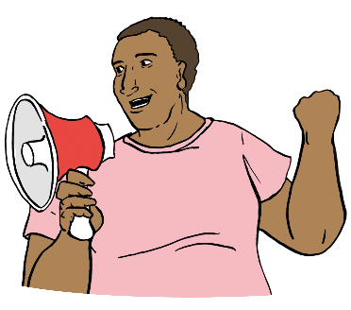
“There are many survivors present that have fought tirelessly for this day to arrive.”


Tirelessly means working hard without giving up.

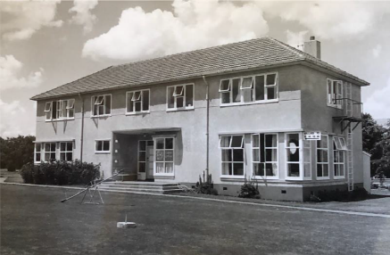
“We all know of Paul Zentfeld and the mahi he did to highlight the torture and abuse that occurred at Lake Alice.”


Highlight means to show to others something they may not have seen.


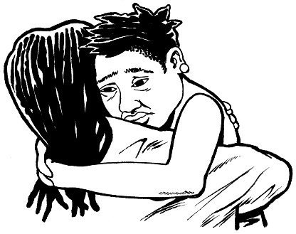
“And Hake Halo who sent a letter to his mum by drawing a stickman cartoon character with a caption in Niuean saying ‘mum the man is putting wires in my head from a machine and it hurts’ which initiated the beginning of the end for Lake Alice.”


Initiated means started.

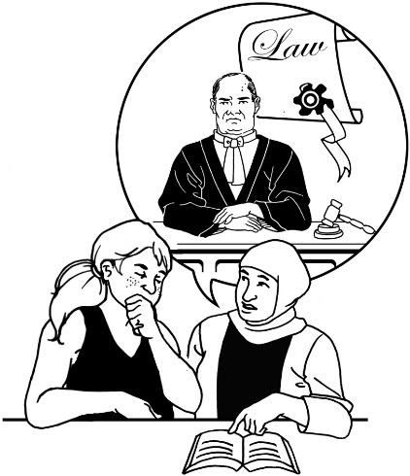
“Leonie McInroe who started the first civil litigation against the Crown for the horrendous abuse and torture she suffered at Lake Alice only to be stonewalled by the Crown tactics for over 9 years.
She is still fighting for justice.”
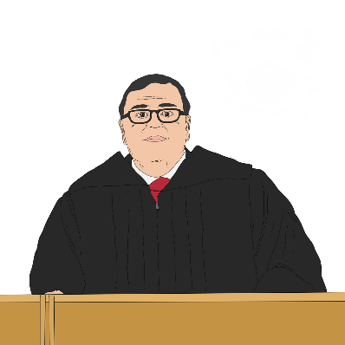

Civil litigation is when a person chooses to take someone to court for something they have done.
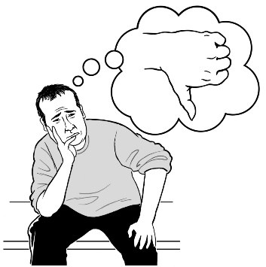

Horrendous means something is very bad.


To stonewall someone means to do choose to do things that will slow someone down on purpose.

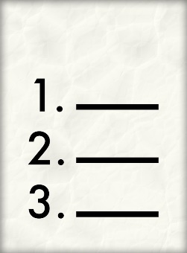
Tactics in this quote means the things the Crown did to stonewall Leonie.
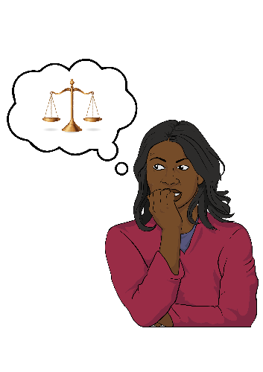

Justice means making sure that things that have been done wrong are made right.

“I want to acknowledge Alby Epere and his wife April Mokomoko whose heartbreaking interview led to many coming forward at the beginning of the Royal Commission of Inquiry.”
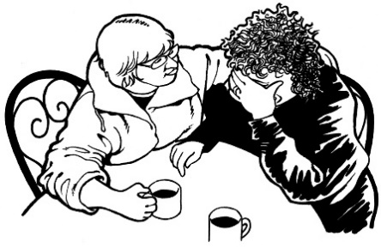

Heartbreaking means very upsetting.

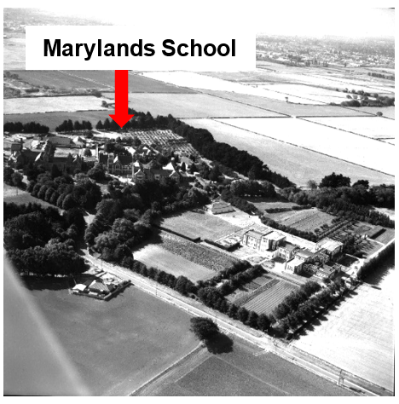
“Also those in the faith based survivor community like Darryl Smith, Eddie Marriott and their fellow students for bringing out into the open the atrocities and despicable acts of abuse at Marylands - St John of God institutions.”

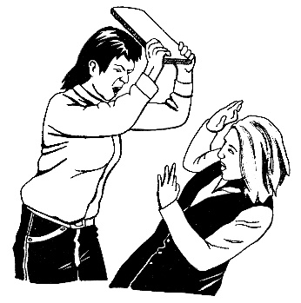
Atrocities are bad things people have done that are:
very nasty
things that someone nice would not do.

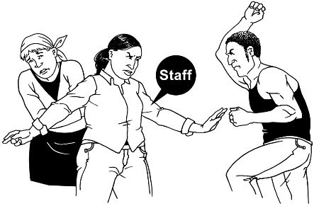
Despicable acts are bad things people have done that most other people would:
find horrible
never do.
[I want to acknowledge]

“Also my Pasifika sister Frances Tagaloa who keeps reminding us about Faith-based abuse.”

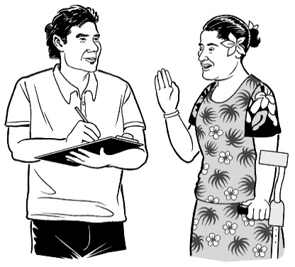
“Paora Moyle who spoke straight from the hip forever keeping the Royal Commission of Inquiry
on their toes.”

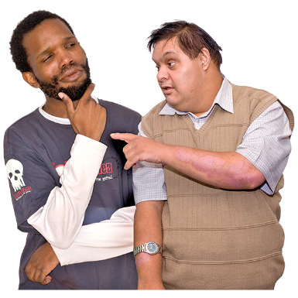
To speak straight from the hip means to say things in ways that:
are clear
are honest
explain what they think.
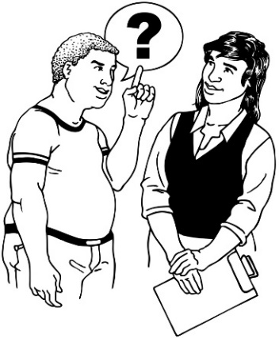

To keep someone on their toes means doing things to make sure someone does what they must do.
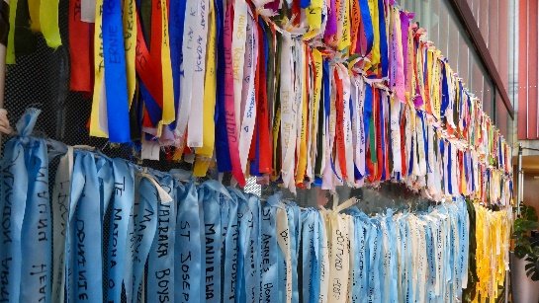
[I want to acknowledge]

“Kath Coster and her survivor ribbons.”

The survivor ribbons made by Kath Coster have the names of survivors written on them.

They were taken to parliament for
the apology.

“I will always stand in support of our gang whānau who thousands of us joined after we were abused and neglected by the state.

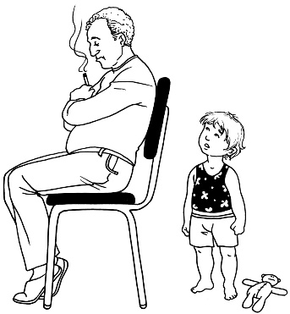
I was one of them.”

Neglected means not taken care of.

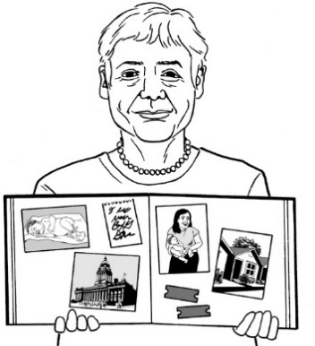
“So many survivors to thank and to each and every one of our thousands of brave survivors who came forward to recount your story of abuse to the Royal Commission of Inquiry I say fa’afetai fa’afetai fa’afetai tele lava thank you thank you thank you.
Without you there would have been no today.”

To recount means to tell a story
from your memories.

“And to all those thousands of survivors, who, for whatever reason did not come forward, we did it for you, we’re here for you.

Kia kaha.”

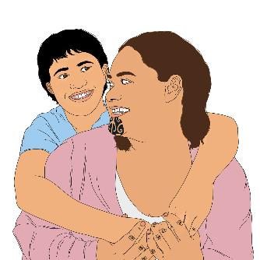
“Over the past 4 months, 2 Taonga pieces were produced to forever represent survivors of abuse in care.”
These were made by 2 wāhine survivors.”
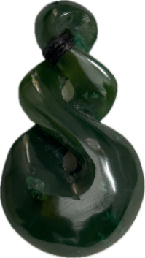

Taonga means treasure in te reo Māori.


To have something represent survivors means an items that reminds other people of what survivors went through.

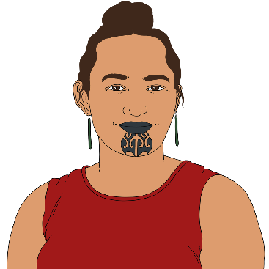
Wāhine means women in te reo Māori.


“Ngā Rākau Rikiriki written by Te Pare Meihana is a book of poems that recounts and represents survivors stories.”

“Deeply personal, often harrowing reading if you get a chance, sit with it and be grateful that wasn’t you.”


Harrowing means something very:
upsetting
painful.

[The Ngā Rākau Rikiriki book]
“It echoes the sentiments that if survivors had been nurtured and loved, cared for by the state instead of discarded and ignored, we could have reached our full potential but we weren’t and here we are today.”
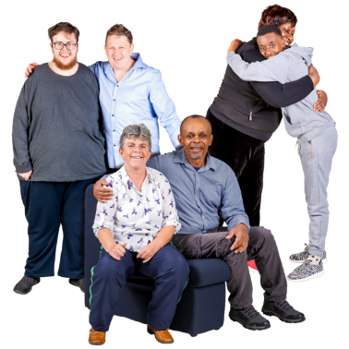

Nurtured means to be cared for as you grow.


Discarded means to be:
thrown away
treated like you do not matter.


For someone to have reached their full potential means that person became the best person they could be.

“He Kakano i ruia mai a Rangiatea - it means ‘The sacred seeds that have descended from the heavens’.
Produced by Charmaine Anaru of Oamaru stone and tōtara, it speaks to the innocence and purity of newborn babies, with a scent that is bestowed upon us all at birth.”

Descended means something has come down from a high place.

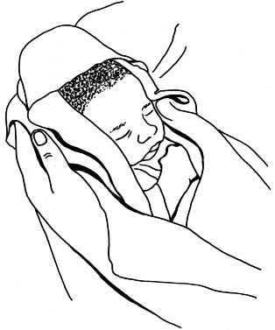
The innocence and purity of newborn babies is about how newborn babies:
do not know about the bad things in the world. what they need.

Bestowed means given to.

“The bottom half of this sacred seed is woven muka thread, extracted from the harakeke.
This represents how survivors are connected from all walks of life.”

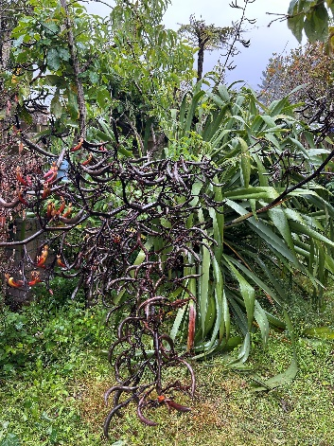
Muka thread is a white thread made from harakeke / New Zealand flax.
Harakeke is the te reo Māori name for the New Zealand flax plant.

“The two tāniko woven kete on the side of the seed holds the bravery, courage and strength of survivors as we endured some of the most horrific and despicable acts of
abuse that left a lifetime of trauma.”


Woven kete are bags made with flax that are important to Māori.

Tāniko woven kete have:
extra details done with threads called embroidery
special patterns made with shapes with straight lines called geometric shapes.

“The cavern has a rough exterior, similar to that which we have built as survivors to protect us from what we have had to endure.


Exterior means the outside of something.

Endure means to make it through something hard.
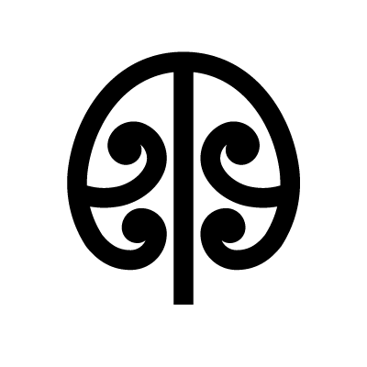
The poupou are carved depicting the mangōpare [the hammerhead shark].

The mangōpare lives in the deepest darkest water unchallenged.”
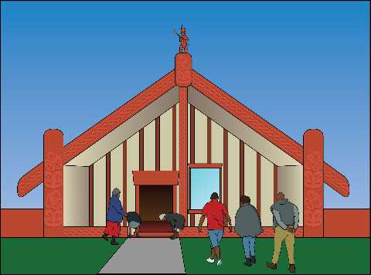

Poupou are the carved walls of a Māori meeting house / Marae.


Depicting means showing.

Unchallenged means nothing will fight it.

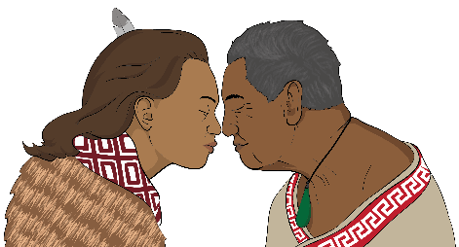
“This taonga has a mauri (life force) that needs to be kept alive and not put into some backroom to collect dust.”
I appeal to the Prime Minister and the Lead Minister Erica Stanford to commit resources so the taonga can travel around the regions.”


Mauri is the life force / energy passed down from our ancestors.

Every living thing has its own Mauri.

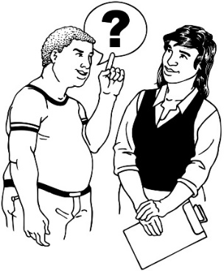
To appeal to someone means to ask them to do something.


To commit resources means to agree to make sure there is money
to do something.
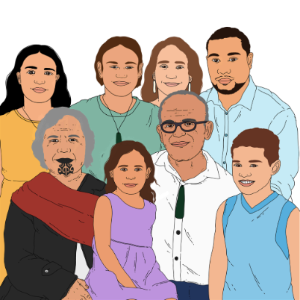

“A tangible action that would allow survivors to come together in a meaningful way to support one another under the mauri of the taonga.”


A tangible action is when you do something that:

can be seen
is noticed by people
is real.

“The taonga, like survivors, must not be shut in the dark.

They can act as the conduit to bring our whānau into the light.”
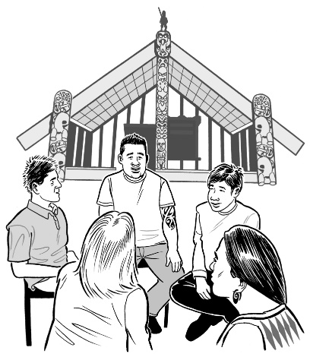

A conduit is something that:
connects things
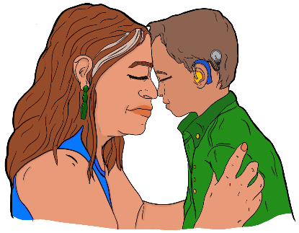
allows things like mauri to pass through it as part of that connection.

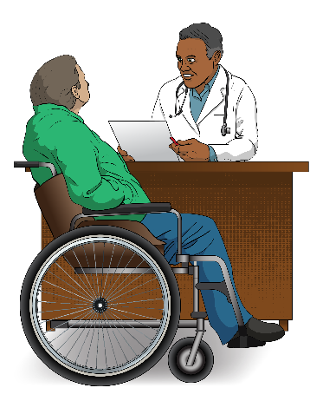
“Many of us have learnt to live with our un-diagnosed trauma to the point it became a part of who we are.”

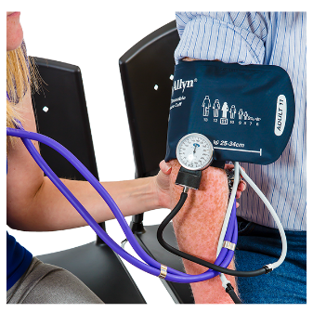
To be diagnosed means that a doctor has said you have a medical condition.

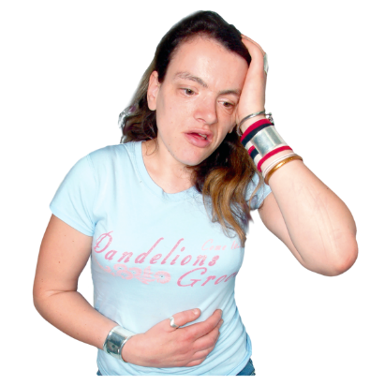
Un-diagnosed means that someone has a medical condition that has not been diagnosed by a doctor.

“Six years ago, the Royal Commission of Inquiry came along and survivors were asked to tell their stories as a part of the evidential collection process.”

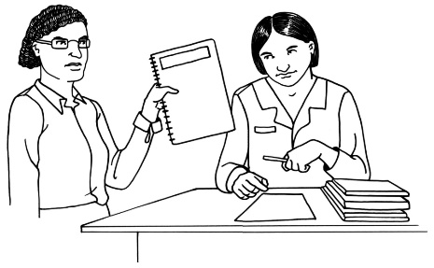
An evidential collection process is when a group like the Royal Commission works to find information to show something has happened.


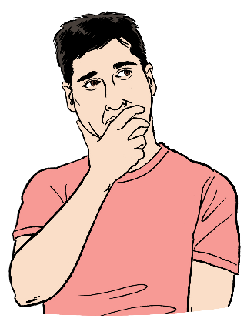
“Many of us were conflicted to do so, including myself.
On the one hand we had buried the trauma and just wanted to leave it there.
It hurts to dig around the pain.”

Conflicted means not being sure of what choice you should make.
“But beyond that we wanted, needed and were owed some accountability for what had happened to us.
So we took those first steps.

And today we will finally see what accountability could look like.”


Accountability means that
someone will take the blame if
something goes wrong / a bad thing happens.


“I know that for my survivor whānau there are huge expectations for this day and beyond.
The most important being that the redress will include an outcome that will keep our mokopuna safe from any further harm.
That is the one non negotiable.

You, the state, must commit to that.”
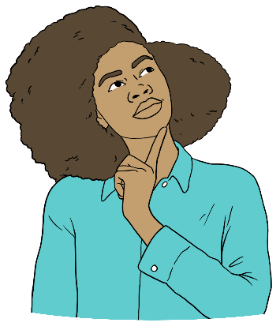

Expectations are things that people think will happen.

Mokopuna means the children of your children like:
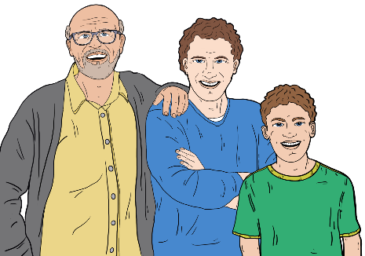
grandchildren
grand-nephews / grand-nieces
great-grandchildren.

Non-negotiable means that this must be part of what happens next.


To commit to something means to promise you will do something.

“My brothers and sisters of te whānau mōrehu, we can’t do anything about the abuse we suffered at the hands of the State but we can be responsible for our healing.


Regardless of what happens
today it is our collective power
that will contribute most to our healing journey.
We owe ourselves that.”


Regardless of what happens today means no matter what happens today.

Collective power means what you can do because you are:
part of a group
not alone.

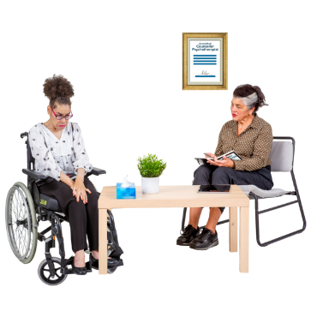
A healing journey means the things people do to heal from their trauma.

“To the other side of this shit fight, to you, the state - you owe us too. It’s not enough to say sorry.

As any good parent knows, it’s what you do to heal the wounds of your actions and make sure it never happens again that really counts.
Make it count.”

This information has been written by Fa’afete Taito.

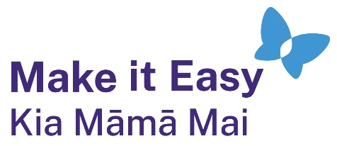
It has been translated into Easy Read by the Make it Easy Kia Māmā Mai service of People First New Zealand Ngā Tāngata Tuatahi.
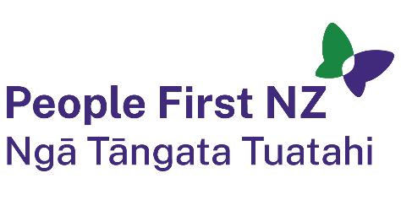
The ideas in this document are not the ideas of People First New Zealand Ngā Tāngata Tuatahi.
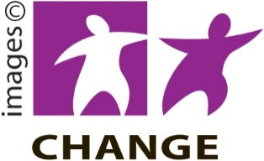
Make it Easy uses images from:
- Changepeople.org


            - Photosymbols.com



- SGC Image Works
- Huriana Kopeke-Te Aho
- T. Wood.

All images used in this Easy Read document are subject to copyright rules and cannot be used without permission.

