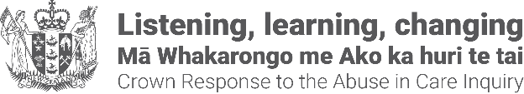
Pānui: Changes are coming to State redress
Adapted in 2026 by Accessible Formats Service,
Blind Low Vision NZ, Auckland
Transcriber's note: The logo at the top of the page is the New Zealand Government coat of arms, followed by the words "Listening, learning, changing. Mā Whakarongo me Ako ka huri te tai. Crown Response to the Abuse in Care Inquiry."

Pānui: Changes are coming to State redress
22 July 2026
Kia ora Koutou
This week marks two years since the release of Whanaketia—Through Pain and Trauma, From Darkness to Light, the Royal Commission of Inquiry into Abuse in Care's final report.
Whanaketia followed the Commissions' interim redress report He Purapura Ora, he Māra Tipu: From Redress to Puretumu Torowhānui, released in December 2021. Together, the reports set out findings and recommendations to address the wrongs of the past, improve the safety of care systems, and better support those in care, their whānau and communities.
In this pānui, we provide updates on work to address the wrongs of the past.

Changes to are coming to State redress
Improvements to the State redress service will soon be introduced to make the redress system easier to access, easier to understand, and more consistent for survivors seeking redress for abuse or neglect in State care.
The service will provide a single point of contact for people seeking information about:
- State redress
- how to make a new claim
- updates on an existing claim
If a person's experiences involve more than one State care setting or government agency, agencies will work together to provide a more joined-up response.
The service is designed to reduce the need for survivors to repeat their experiences. Based in the Ministry of Social Development, it will provide a clear point of contact throughout the redress process.
The State redress service will also change how government agencies work together. This includes changes to how survivor information is collected, used, and shared to support a more joined-up, survivor-centred experience when registering a new claim.
Existing claims will continue as normal, and people do not need to take any action at this stage.
Read more about the upcoming changes, how information may be used, and what this means for existing and future claims:
https://www.redress.govt.nz/upcoming-redress-changes
[or at the short link https://tinyurl.com/4u84zhh7]

More information
Please feel free to share this pānui. People can sign up to receive these updates.
- Send us an email with "Pānui newsletter" in the email subject line to: contact@abuseinquiryresponse.govt.nz
- Or write to:
Crown Response Office
Te Kawa Mataaho Public Service Commission
PO Box 329
Wellington 6140
If you no longer want to receive these pānui, please email or write to us and "unsubscribe".

Alternate formats of the pānui can be found on the Crown Response Office website:
https://www.abuseinquiryresponse.govt.nz/news/alternate-formats [or at the short link: https://tinyurl.com/j444kpsa]
End of Pānui: Changes are coming to State redress

