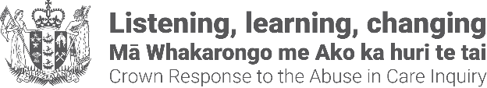

Pānui newsletter update about the Crown response
18 March 2026
This pānui/newsletter is from the Crown Response Office. We coordinate, monitor, and report on the government’s response to the Abuse in Care Royal Commission of Inquiry.

Update on the Government’s response to the Abuse in Care Royal Commission’s recommendations
The government’s response to the Abuse in Care Royal Commission’s recommendations covers three areas: addressing the wrongs of the past, making the care system safe, and empowering those in care, their whānau and communities.
In this newsletter, we have provided an update about addressing the wrongs of the past.

State redress system to include mental health redress claims
The Government has agreed to extend the core State redress system to include survivors of abuse in the following State-run mental health facilities from 1 July 1993 to 30 June 2022:
- State-run psychiatric and mental health facilities, including general mental health wards.
- State-run psychopaedic (intellectual disability) care settings, including Kimberley Hospital / Centre (closed in 2006).
It does not cover:
- General hospital wards.
- Aged care.
- Off-site or outpatient care (for example, care delivered at home).
- Care and treatment failures (as distinct from abuse).
Until changes are implemented, survivors with questions or potential claims should contact:
- Email: historicabuse@health.govt.nz
- Freephone: 0800 400 569
This decision forms part of the Government’s decisions on redress for wider State and non-State survivors. The Crown Response Office proactively released a Cabinet paper about this work on the Crown Response Office website. You can access this by typing in the short url:
https://tinyurl.com/mrx8z5pj
You can read the Lead Coordination Minister Erica Stanford’s press release by typing in this short url:
https://tinyurl.com/mrx42mmn

Support
As a reminder, there is a Survivor Experiences Service for people who were abused in State, faith-based, or other forms of care, as well as for a survivor’s whānau.
Survivors and whānau can contact the Survivor Experiences Service to organise a time and place to share their experiences or for records support.
- call 0800 456 090
- text 8328.
- Email contact@survivorexperiences.govt.nz
Please feel free to share this pānui newsletter. People can sign up to receive these updates: contact@abuseinquiryresponse.govt.nz with 'pānui newsletter' in the email subject line.
Alternate formats of the pānui newsletter can be found on the Crown Response Office website, if you type in this short url: https://tinyurl.com/j444kpsa
End of information | Pānui newsletter update about the Crown response
This Large Print document is adapted by Blind Citizens NZ from the standard document provided by the Crown Response Office

