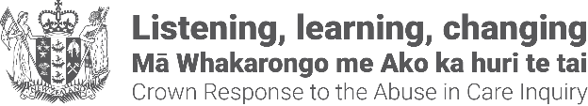

Pānui newsletter update about a common payment framework
Tuesday 27 January 2026
This pānui/newsletter is from the Crown Response Office. We coordinate, monitor and report on the government’s response to the Royal Commission.

Updates on the Government’s response to the Royal Commission’s recommendations
The government’s response to the Royal Commission’s recommendations covers the following three areas: addressing the wrongs of the past, making the care system safe, and empowering those in care, their whānau and communities.
In this newsletter we have provided an update about addressing the wrongs of the past and the development of a common payment framework.

A common payment framework
Survivors seeking a settlement payment for abuse and/or neglect in State care will benefit from a clear, consistent and fair approach that reflects the severity and frequency of the abuse and or neglect they experienced, irrespective of where they were in care or when the abuse or neglect occurred.
A Common Payment Framework (the Framework) has been developed and is being used by redress agencies following completion of the assessment process of their redress claims.
The Framework replaces the previous practice of agencies using their own framework or ways of determining payments. This practice was heavily criticised by survivors for the differences in payment amounts for similar types of abuse and or neglect, and the lack of transparency about why the amounts were different.
There are two sections to the Framework:
1. Payment categories. The categories set out what payment will be offered for what kind of abuse and neglect.
2. Definitions of abuse and neglect. The definitions explain key terms used in the payment categories.

For more information
Read a summary, type in the short url: https://tinyurl.com/2s378pv3
To download type in the short url: https://tinyurl.com/2dwke872
[The document is not in alternate format]
Distressing content warning: The information contains definitions about abuse and neglect and may be distressing for some readers.
You can find information about support available here:
Support available | Crown response to the Abuse in Care Inquiry and https://tinyurl.com/mr3uzmfm
As a reminder, there is a Survivor Experiences Service for people who were abused in State, faith-based, or other forms of care, as well as for a survivor’s whānau.
Survivors and whānau can contact the Survivor Experiences Service to organise a time and place to either share their experiences or seek records support.
- call 0800 456 090
- text 8328.
- Email contact@survivorexperiences.govt.nz
To find out more about the Survivor Experiences Service, visit: www.survivorexperiences.govt.nz
Alternate formats of the pānui newsletter can be found on the Crown Response Office website. Type in the short url: https://tinyurl.com/j444kpsa

Contact details
general enquiries email: contact@abuseinquiryresponse.govt.nz
postal: Crown Response Office, Te Kawa Mataaho Public Service Commission, PO Box 329, Wellington 6140.
End of information | Pānui newsletter update about a common payment framework
This Large Print document is adapted by Blind Citizens NZ from the standard document provided by the Crown Response Office

