
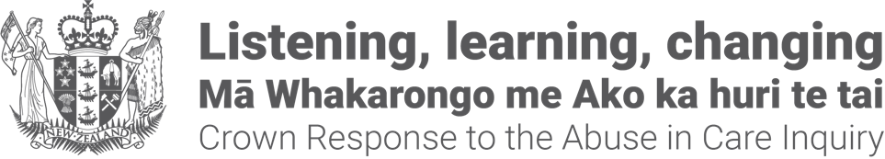

Crown Response Office
Pānui / Newsletter


Published: June 2025

Before you begin


This Easy Read talks about abuse.

This information may upset some people when they are reading it.



This information is not meant to scare anyone.


If you are upset after reading this document you can talk to your:
whānau / family
friends.

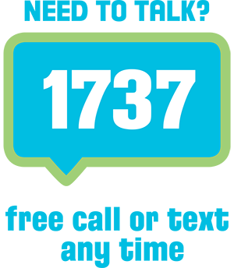
You can also contact Need to Talk by:
calling 1737
texting 1737


It does not cost any money to
call / text 1737.

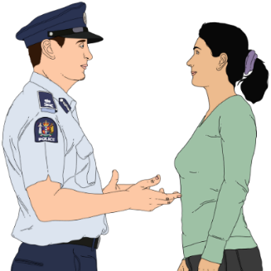
If you do not feel safe call the police on 111

About this Easy Read


This Easy Read is a
pānui / newsletter from the Crown Response Office.


The Crown Response Office is in charge of the Government response to the Royal Commission of Inquiry into Abuse and Neglect in Care.

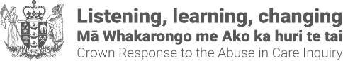
It is sometimes called the CRO.


Here response means what the Government is doing because of what the Royal Commission of Inquiry found out about the abuse and neglect of:
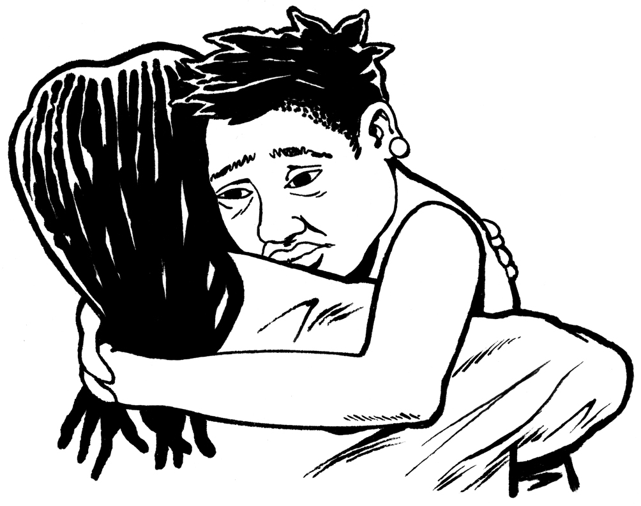
children
young people
vulnerable adults.


Abuse and neglect can be:
physical – a person kicking or hitting you
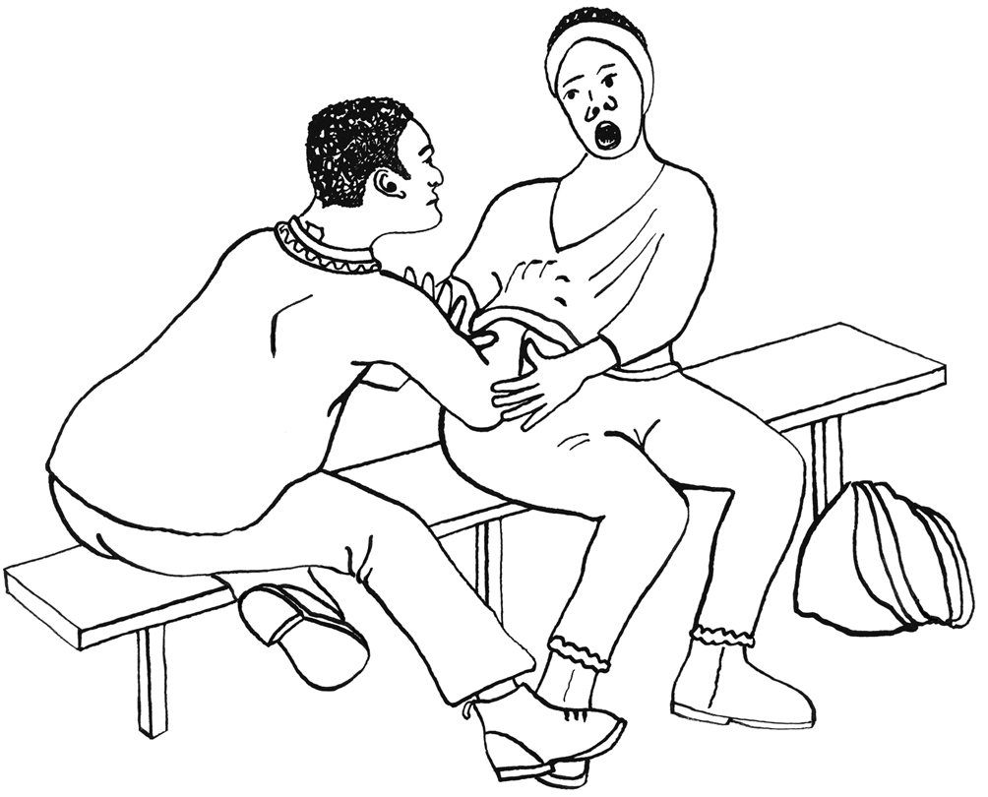
sexual – a person doing sexual things to you that you do not want them to like:
- touching your body or private parts
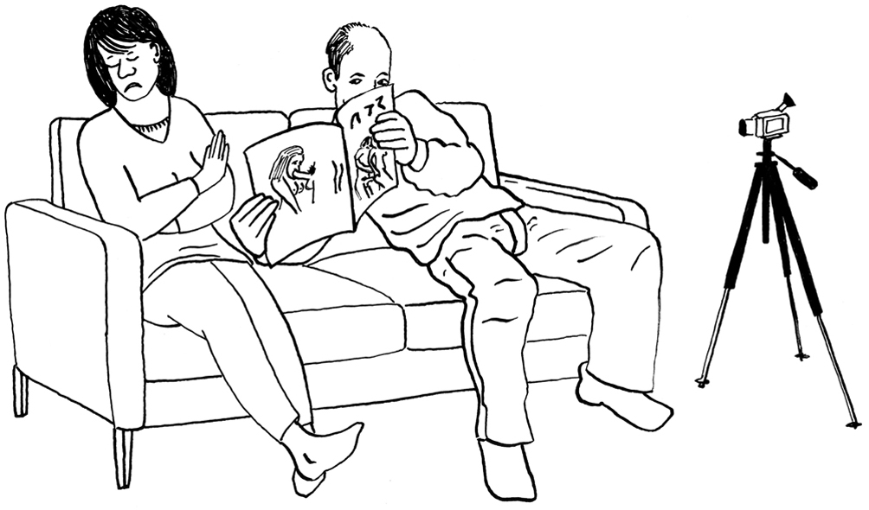
- kissing you
- making you have sex with them – this is called rape
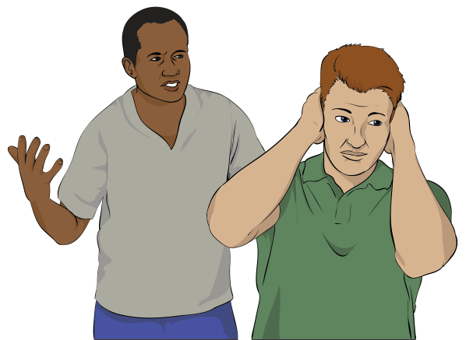
emotional – a person yelling or saying things to you that are not nice
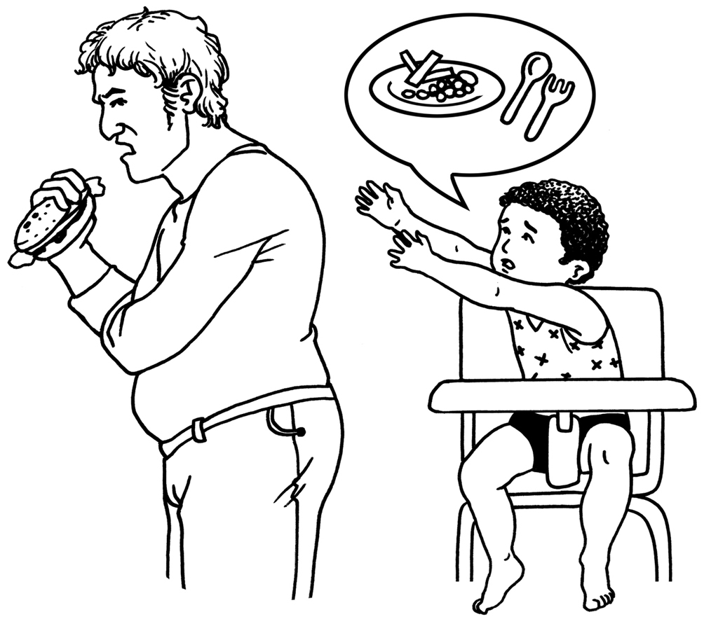
a person not giving you the things or care that you need.


This pānui / newsletter is about improvements being made by the Government to the:
redress system.
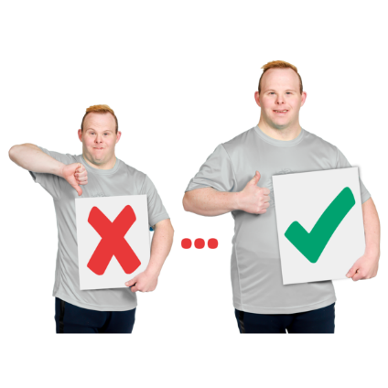
care system.

Improvement means changing something to make it work better.

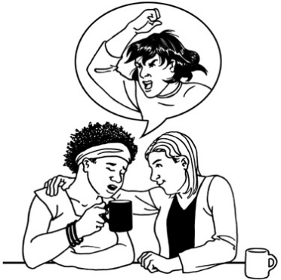
Redress means someone:
agrees that something bad has happened
does something to try to:

- put things right
- make up for any harm that has been done.


Redress can be things like:
saying sorry
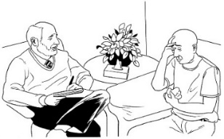
giving money as a way of saying sorry
giving other kinds of support like counselling.


You can read more CRO
pānui / newsletters from the CRO at this website:

https://tinyurl.com/25mt2z4n

What are the redress improvements?

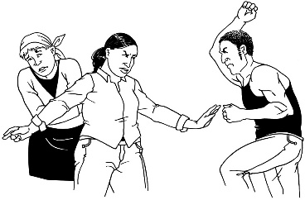
The Government has said they are making improvements to the redress system to respond to / do something about abuse in care.


Money for claims

Here claim means asking the Government for redress.


The Government is making the average amount of money paid out for a claim bigger.


The average amount of money paid out for a claim will be 30 thousand dollars.


The average amount has been worked out by looking at all the money paid for claims from all government agencies.
$$
$$


This is for:
claims being sorted out now
new claims.
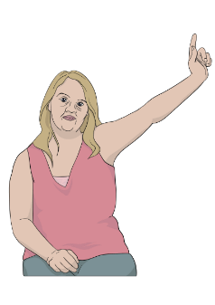

$$

A survivor with a claim that is
closed / finished can ask for a top-up payment.


People who have been through abuse in care are called survivors.

Here a top-up payment means survivors get an extra payment on top of what they have already been paid.


Survivors with a closed / finished claim can register to find out if they can get a top-up payment at this website:

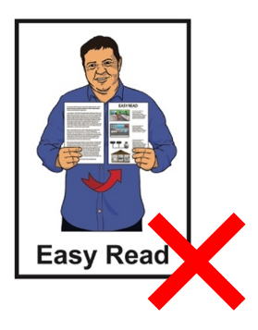
www.abuseincaretopups.govt.nz

This website is not in Easy Read.

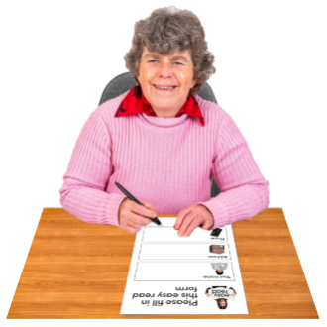
Register means to put your name down for something.


Survivors can also register by phone on:

0800 867 877



This number does not cost money to call.


This phone number can be called from:


Monday to Friday
8 in the morning to 5 in the afternoon.


If you do not live in Aotearoa New Zealand you can phone:

+64 4 931 1678

This number costs money to call.


Dealing with claims

The improvements mean more claims can be processed / sorted out by the Government each year.


Changes to how government agencies work

The improvements mean different parts of the redress system will work more closely with each other.

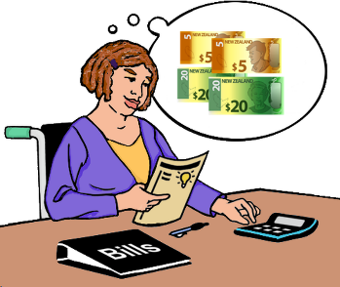
The improvements to services will be things like:

a payment system all agencies can use
looking at ways to make better apologies / saying sorry
help for survivors needing:
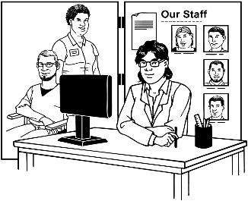
- access to wellbeing
- support with their records.

Here wellbeing means support for:
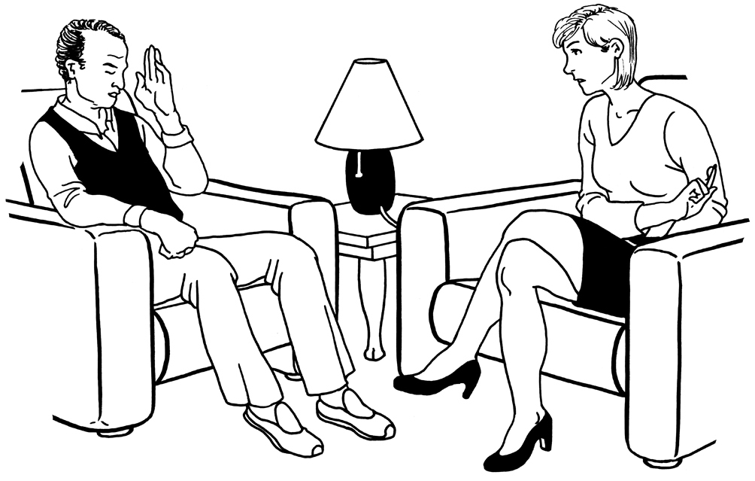
mental health / dealing with feelings
living a good life.


Changing services for survivors

The improvements mean survivors will be able to:

get easier access to redress services
use redress services more easily.

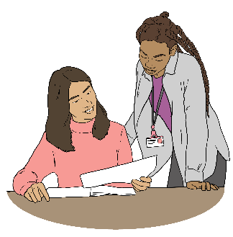
The improvements will be things like:
having 1 place where all government claims are done

survivors making 1 claim instead of lots of claims in different places.

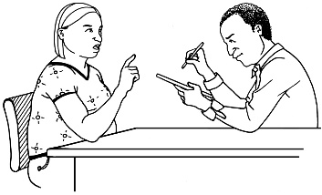
The improvements will also be things like having a way to do:
an independent review if a survivor is unhappy with:

- what is decided about their claim
$
- the money they are offered

reports that use:
- information from all parts of the system
- what survivors say.

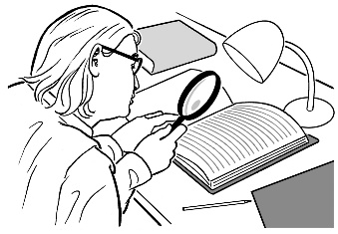
An independent review means someone from outside the organisation:
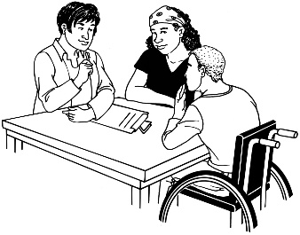
looks at what was done
writes a report about what was done.

Sharing information

A plan for the improvements will be given to Ministers who are part of the redress system in July 2025.

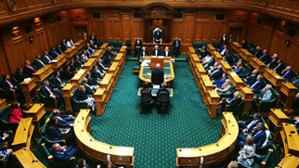
Ministers are people who work for the Government in parliament.


The Government will also set up a Ministerial Advisory Group of:
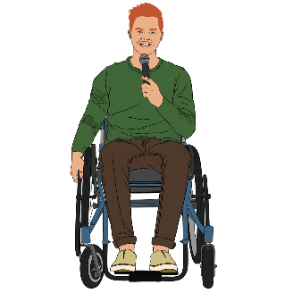
survivors
advocates.


A Ministerial Advisory Group is a group of people who:
know about something

and
give information to government people.

Here advocates are:
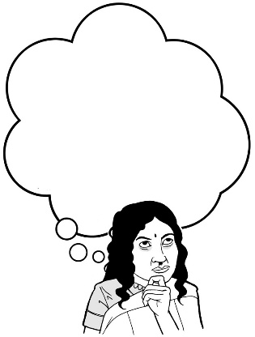
people who know lots of things about:
- abuse and neglect in care
- survivors
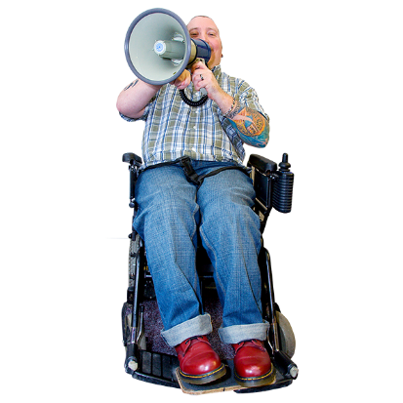
speak up for survivors when the survivors:
- do not want to speak up
- cannot speak up
- need support to speak up.


The Ministerial Advisory Group will give advice to Ministers about the impacts of the redress improvements.

What is the Government doing

about the care system?

Many parts of the government are making improvements to the care system.


Here the care system means all the parts of the government providing care to people.

The care workforce

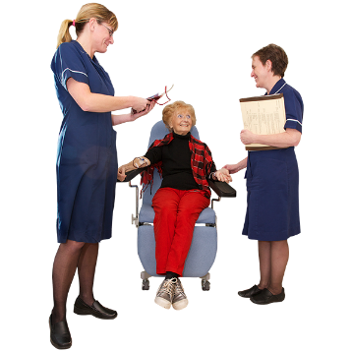
Here the care workforce means all the people:
providing care to someone

or
supporting someone to provide care.
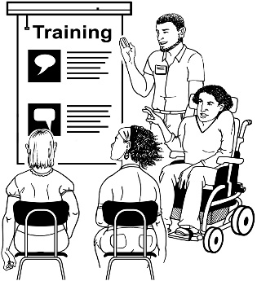
There will be new ways made to train the care workforce.

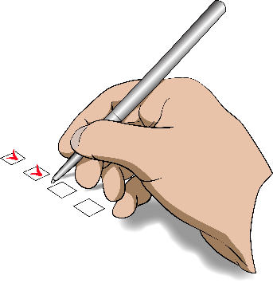
The way we check care workers are safe to work will be reviewed.


Here review means to look at something to:
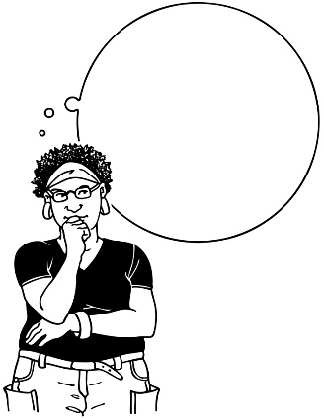

make sure it is the right way to
do it
think about any changes it might need.


After the review better checks to reduce abuse and neglect will be put in place.


These improvements to the care workforce will be done by:

Ministry of Education
Ministry of Health

Oranga Tamariki
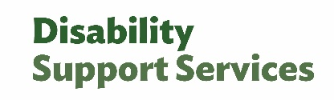
Disability Support Services.

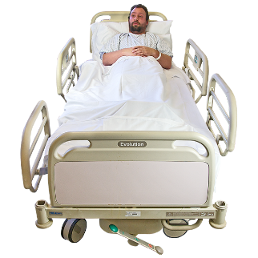
Mental health inpatients

An inpatient is a person who stays at a hospital for more than 1 day while they get treatment.


Health New Zealand will make the places where people get inpatient treatment for mental health safer.

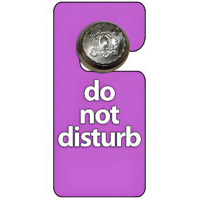
Health New Zealand will also improve privacy for patients.

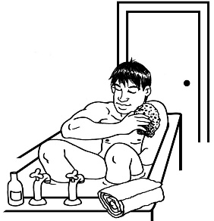
Here privacy means a patient:
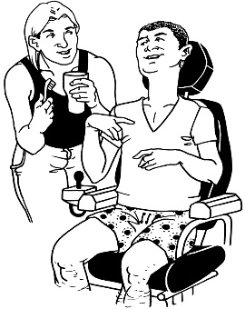
can be on their own when it is safe for them
are only given care by people who need to be there.

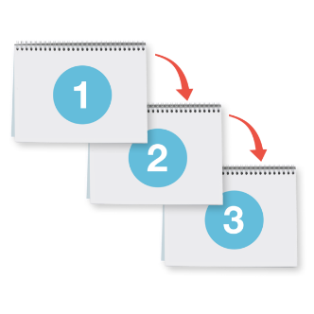
Prevent recognise and respond to abuse in care

The Social Investment Agency will come up with different ways to make sure:
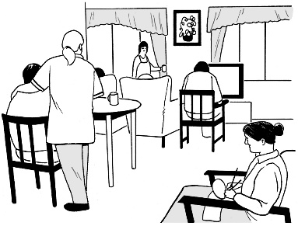
children do not have to go into care

vulnerable adults do not have to go into care.
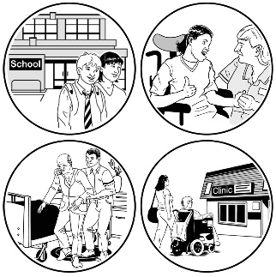
The Social Investment Agency is a government agency that looks at
what is working well
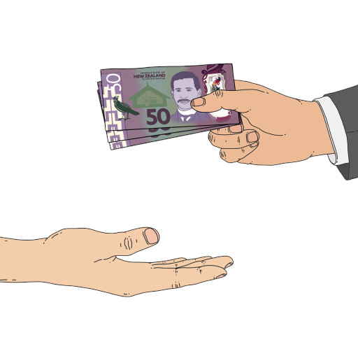
and
recommend where government money should be spent.

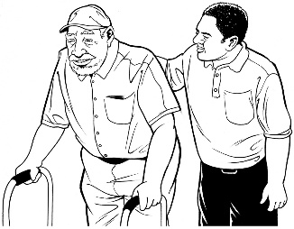
Here vulnerable means a person who:
might not be able to look after themself very well

or
be able to leave unsafe situations.

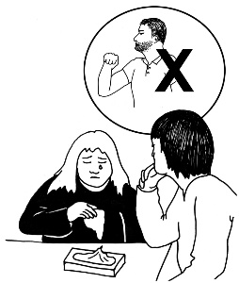
Disability Support Services will make ways of better:
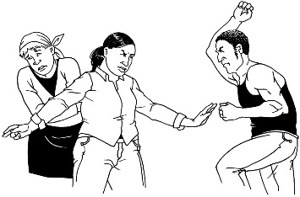
noticing when abuse in care is happening
responding to abuse and neglect in care.


This will be done by:
audits / reviews of contracted care providers

improving the systems to do with:
- critical incidents
- complaints.

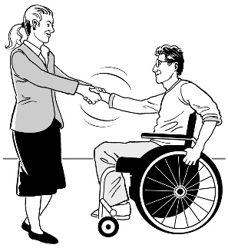
Here contracted means to pay people from outside an organisation to do a job.

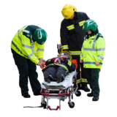
Here a critical incident is when something very serious happens like someone:
gets hurt

dies
does something very wrong.

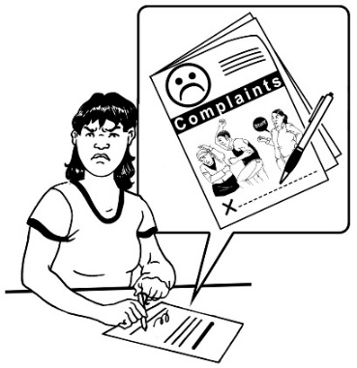
A complaint is when you tell someone:
something is wrong
and
how you want it to be fixed.

Making better records

Funding / money is being given to make better records about care done by the state / government.


This means making sure the rules are followed about how:
records are made / kept
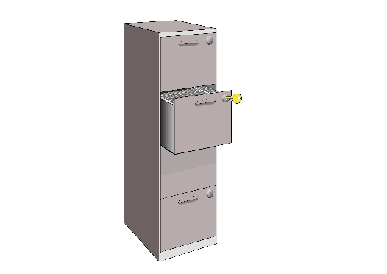
new records are:
- retained / stored
- got rid of.

This is being done together by:
Ministry of Education
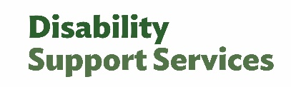
Disability Support Services

Department of Internal Affairs.


Reduce harm to children and young people in care

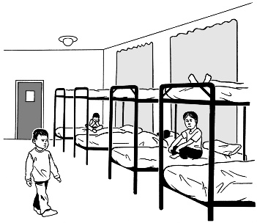
Oranga Tamariki – the Ministry for Children will do work to reduce harm to children and young people:
in community homes

in remand homes
cared for by a caregiver.

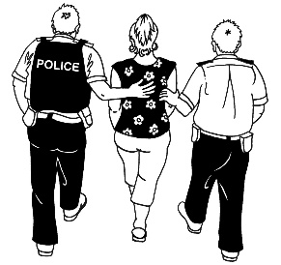
A remand home is where young people might live while they are in the justice system / dealing with the law.

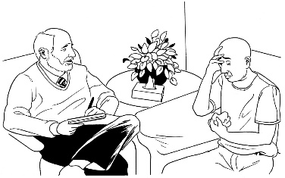
Control of compulsory care

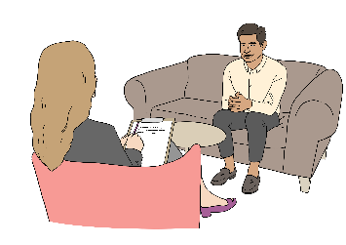

There will be more control of compulsory:

mental health care
addiction care.


Compulsory means being made to do something.

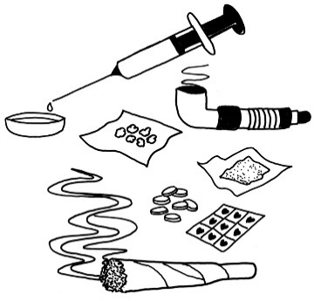
Addiction means not being able to stop yourself from using things like:
drugs
alcohol.

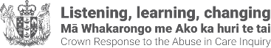
This information has been written by the Crown Response Office.

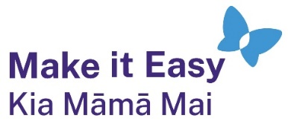
It has been translated into Easy Read by the Make it Easy Kia Māmā Mai service of People First New Zealand Ngā Tāngata Tuatahi.
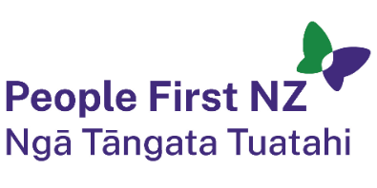
The ideas in this document are not the ideas of People First New Zealand Ngā Tāngata Tuatahi.

All images used in this Easy Read document are subject to copyright rules and cannot be used without permission.


Make it Easy uses images from:

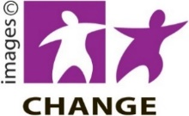
- Photosymbols

- Change Images


- Huriana Kopeke-Te Aho

- SGC Image Works

- T Wood


- Studio Rebeko

- Inga Kramer.

