

Crown Response Office   
Pānui / Newsletter



Published: August 2025

# Before you begin



This Easy Read talks about abuse.

This information may upset some people when they are reading it.



This information is not meant to scare anyone.

If you are upset after reading this document you can talk to your:

whānau / family

friends.

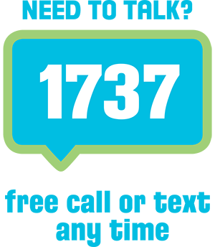You can also contact Need to Talk by:

calling 1737

texting 1737



It does not cost any money to   
call / text 1737.



If you do not feel safe call the police on **111**

# About this Easy Read



This Easy Read is a   
pānui / newsletter from the **Crown Response Office**.

The **Crown Response Office** is in charge of the Government **response** to the Royal Commission of Inquiry into **Abuse** **and Neglect** in Care.



It is sometimes called the **CRO**.

Here **response** means what the Government is doing because of what the Royal Commission of Inquiry found out about the abuse and neglect of:

children

young people

vulnerable adults.

**Abuse** **and neglect** can be things like someone:

hitting you

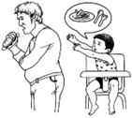calling you names

taking your money

not letting you have the things you need like food.

This pānui / newsletter is about **improvements** being made by the Government to the:

**redress** system.

care system**.**

**Improvement** means changing something to make it work better.

**Redress** means someone:

agrees that something bad has happened

does something to try to:

* put things right
* make up for any harm that has been done.

**Redress** can be things like:

saying sorry

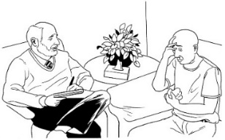giving money as a way of saying sorry

giving other kinds of support like counselling.

You can read more CRO  
pānui / newsletters from the CRO at this **website**:

[**https://tinyurl.com/25mt2z4n**](https://tinyurl.com/25mt2z4n)

# Funding for National Day of Reflection

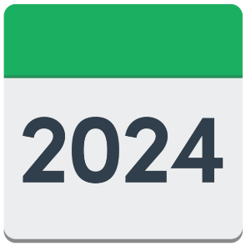

In 2024 the Prime Minister talked about a **National Day of Reflection.**

A **National Day of Reflection** is a way to:

acknowledge / remember **survivors**

let other people know about abuse and neglect in care.



People who have been through abuse in care are called **survivors**.

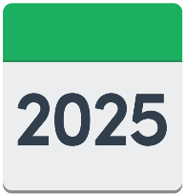

The National Day of Reflection will be on **12 November 2025.**

1 million dollars has been put into funding for organising events for the National Day of Reflection.

This funding is for survivor:

groups

organisations.

There is more information about this funding at this **website:**

[**tinyurl.com/yufz4urm**](https://tinyurl.com/yufz4urm)



This information is **not** in Easy Read.

**Types of events**



The kinds of events / activities that could be funded include:

community gatherings / activities to honour survivors

story telling

art installations – new art work being put in the community

music

cultural performances.

**How to apply for the funding**



To ask for money you must use the online Grants Management System.

More information about the Grants Management System is available at this **website:**

[**tinyurl.com/4bytazst**](https://tinyurl.com/4bytazst)

This information is **not** in Easy Read.



The last time you can ask for money is:

at midnight

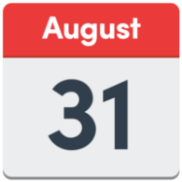

on **31 August 2025**.

# How to ask for Official Information about the Crown response

The Official Information Act is a law that says you can ask for information from government agencies.

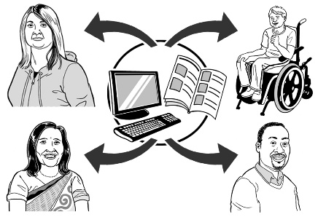

We have already made some information available for **proactive release**.

**Proactive release** is when the Governments makes information available without being asked to.

Before you ask us for information please check to see if we have put it:

on our website here:  
  
[**tinyurl.com/338xpuac**](https://tinyurl.com/338xpuac)

in our old pānui / newsletters which are here:  
  
[**tinyurl.com/3cem58jw**](https://tinyurl.com/3cem58jw)

You can get in touch with us if there is something else you want:

to ask us about

information about.

When you send a question please make sure you clearly write:

your name

your:

* postal address   
    
  or
* email address

what information you want.

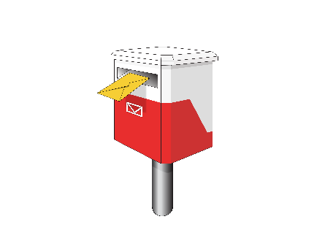You can contact us by:

posting to this address:

**Crown Response Office**

**Public Service Commission**

**PO Box 329**

**Wellington 6140**

emailing us at this address:

[**OIA@abuseinquiryresponse.govt.nz**](mailto:OIA@abuseinquiryresponse.govt.nz)

# Proactive release of decisions about torture redress scheme funding



The **torture redress scheme** is where things are being put right for survivors who suffered very bad abuse.

Information about Government decisions to fund the **torture redress scheme** is now available online here:

[**tinyurl.com/yx78amnw**](https://tinyurl.com/yx78amnw)



This information is **not** in Easy Read.

This information has been written by the Crown Response Office.

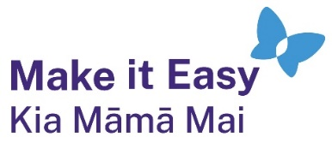It has been translated into Easy Read by the Make it Easy Kia Māmā Mai service of People First New Zealand Ngā Tāngata Tuatahi.



The ideas in this document are not the ideas of People First New Zealand Ngā Tāngata Tuatahi.



All images used in this Easy Read document are subject to copyright rules and cannot be used without permission.

Make it Easy uses images from:

* 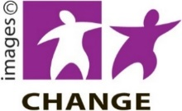Photosymbols
* Change Images
* Huriana Kopeke-Te Aho



* SGC Image Works
* T Wood
* Studio Rebeko
* Inga Kramer.