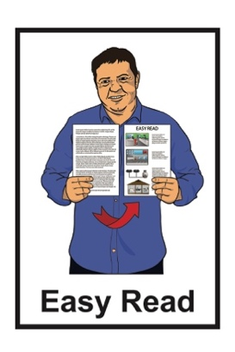
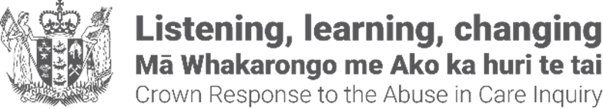

Crown Response Office


New State redress service

Published: September 2026

Before you begin


This Easy Read talks about abuse.

This information may upset some people when they are reading it.
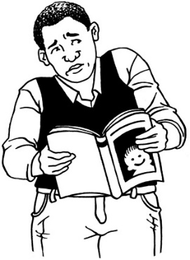


This information is not meant to scare anyone.


If you are upset after reading this document you can talk to your:
whānau / family
friends.

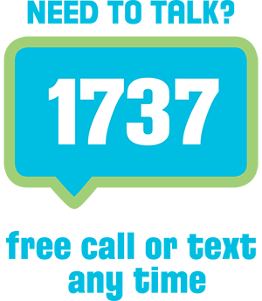
You can also contact Need to Talk by:
calling 1737
texting 1737

It does not cost any money to
call / text 1737.

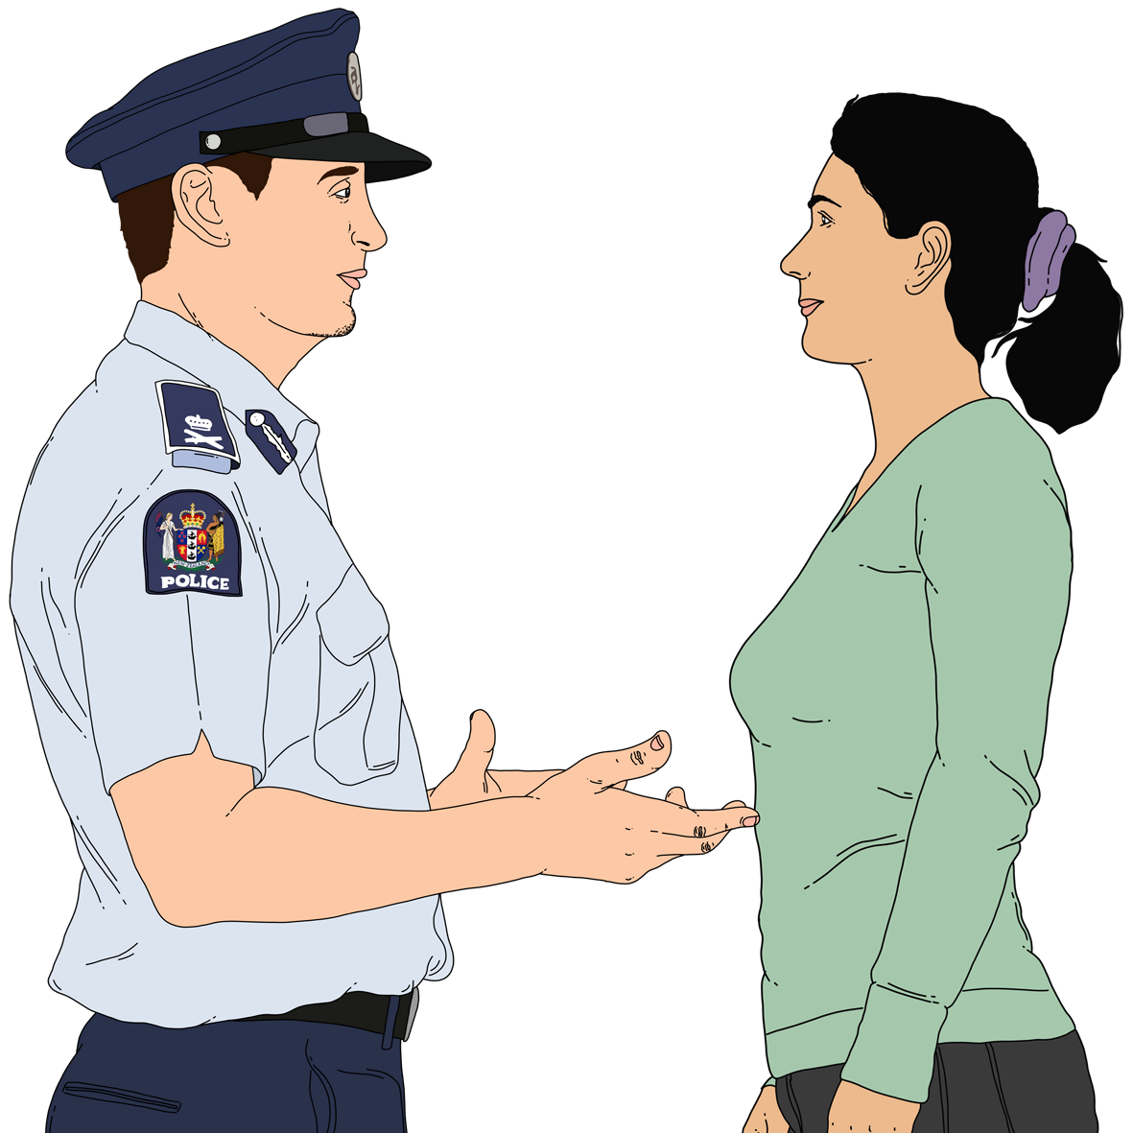
If you do not feel safe call the police on 111.

About this Easy Read

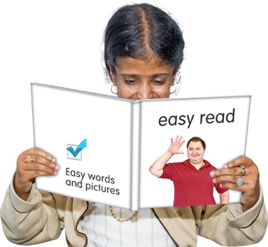
This Easy Read is a
pānui / newsletter from the Crown Response Office.


The Crown Response Office is in charge of the Government response to the Royal Commission of Inquiry into Abuse in Care.

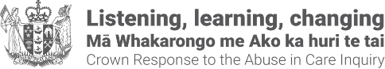
It is sometimes called the CRO.



People who have been through abuse in care are sometimes called survivors.



Here response means what the Government is doing because of what the Royal Commission of Inquiry found out about the abuse of:
children
young people
vulnerable adults.

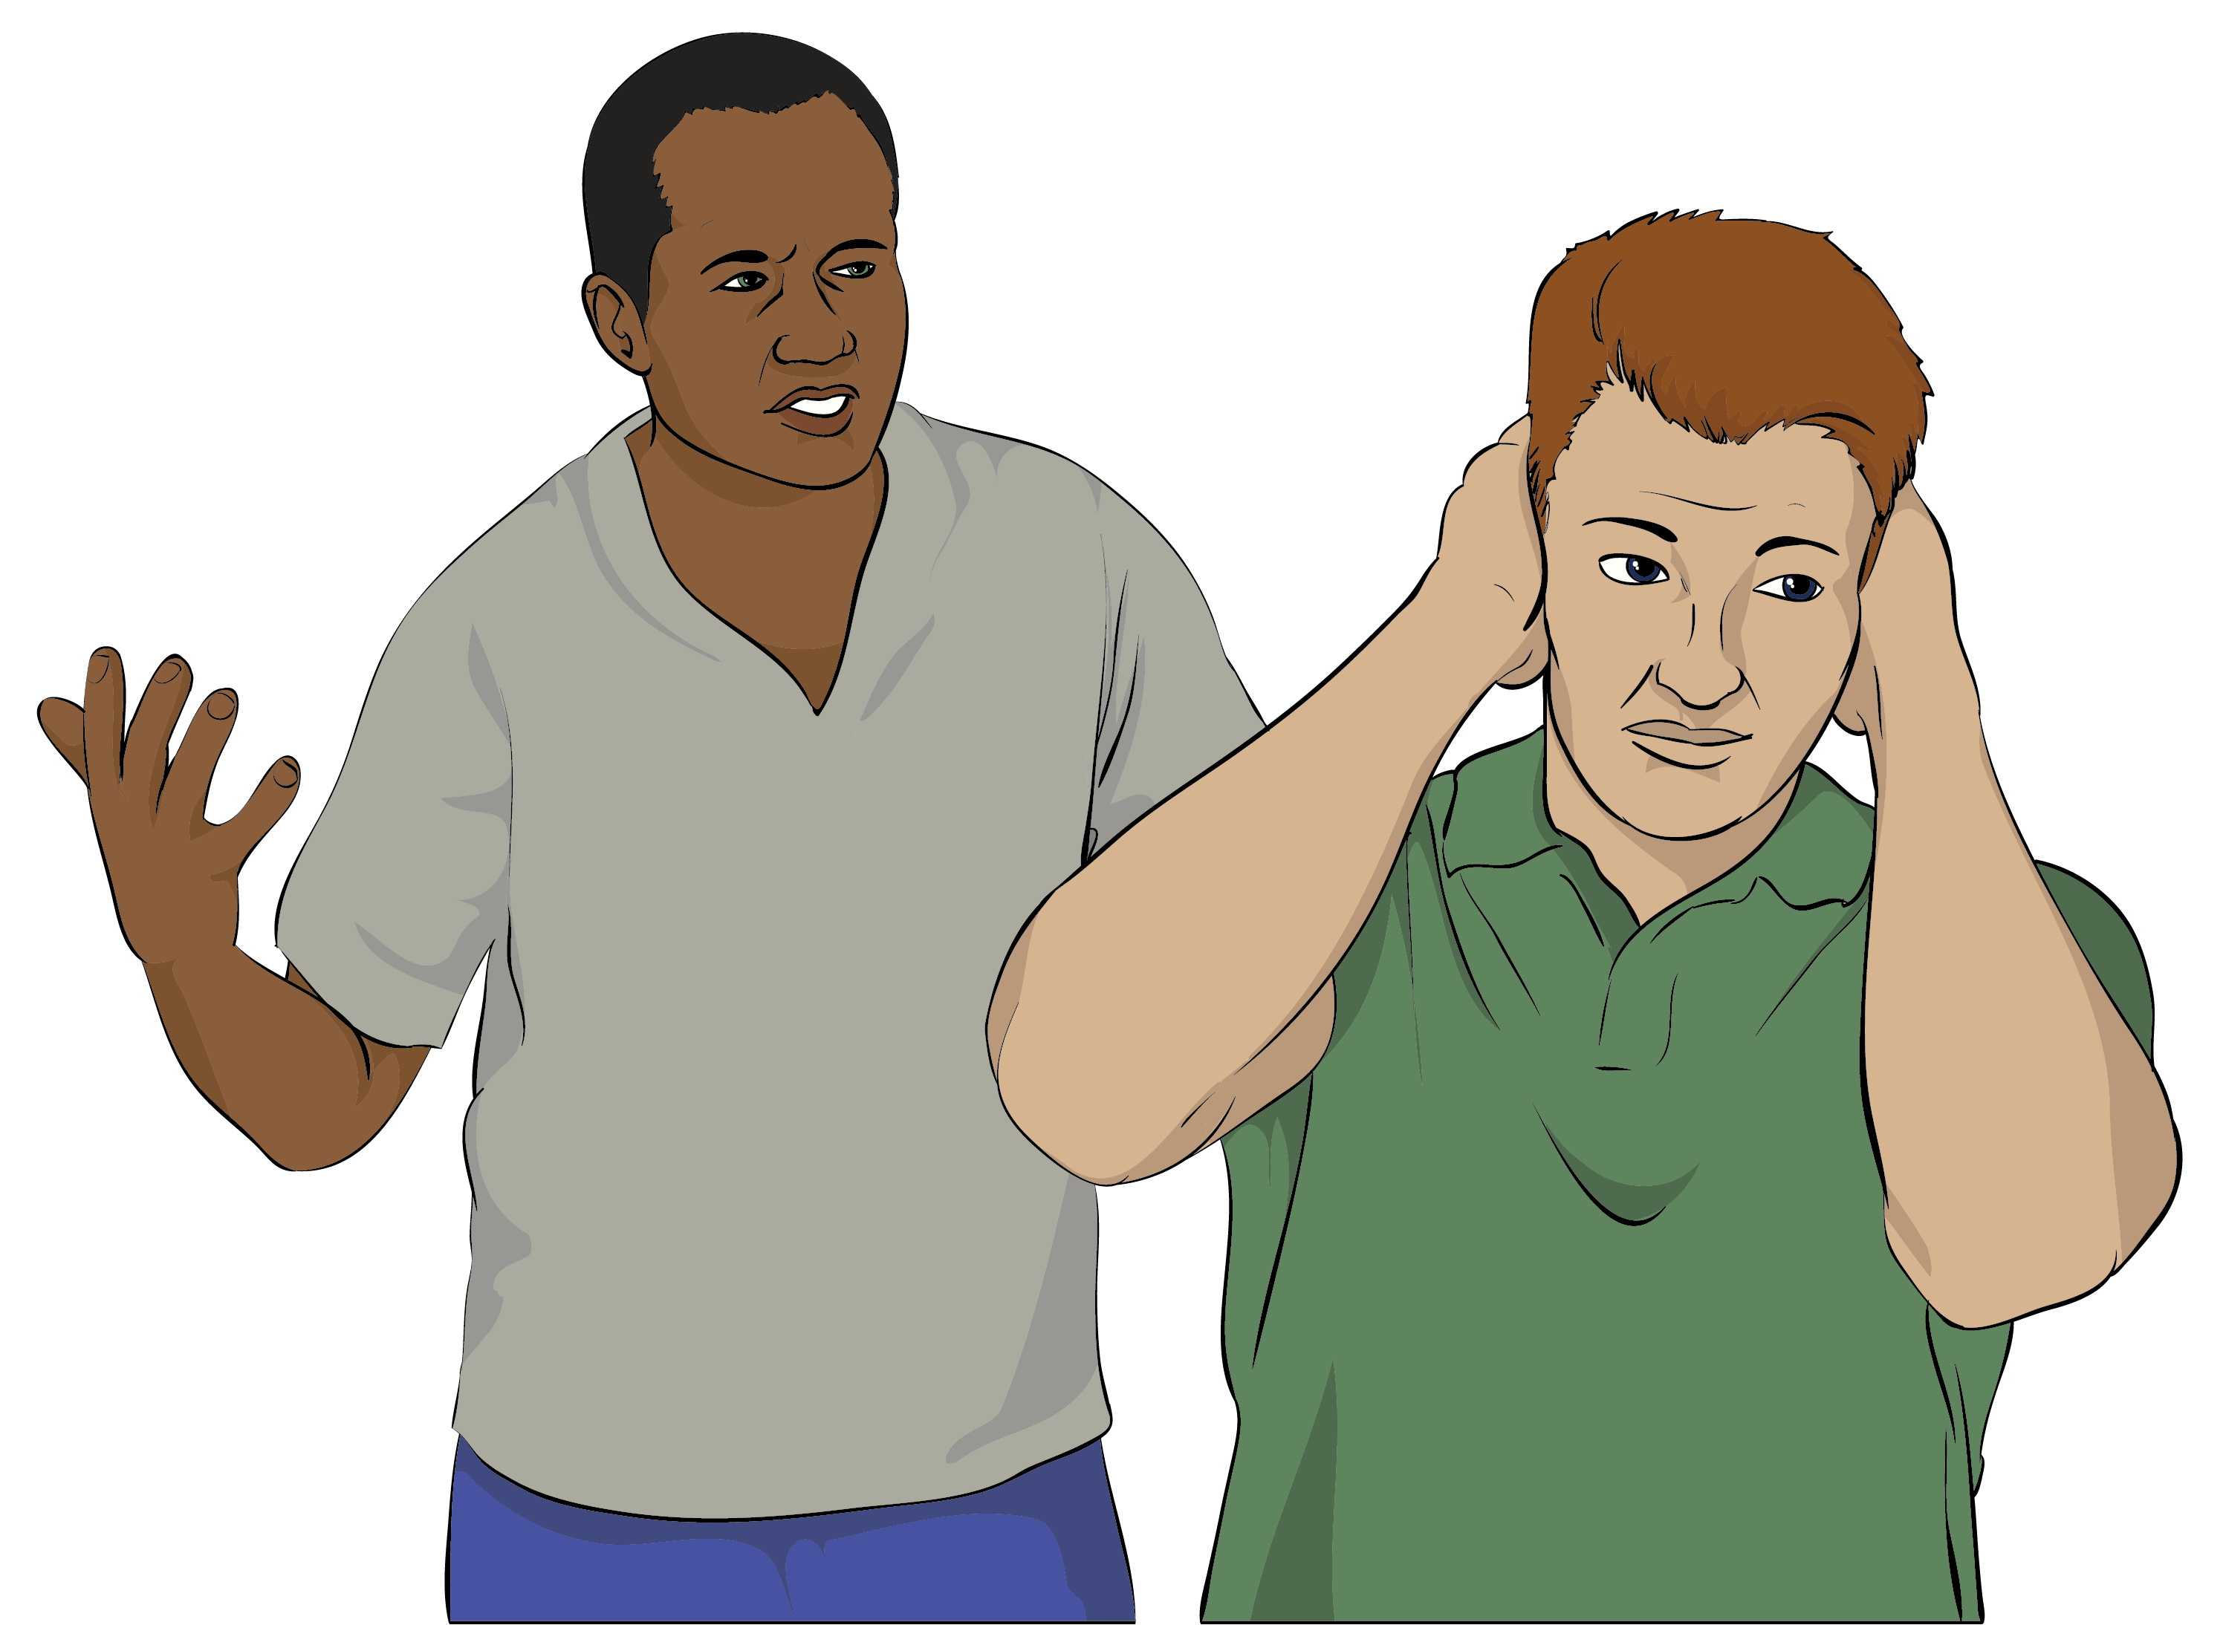
Abuse can be things like someone:
hitting you
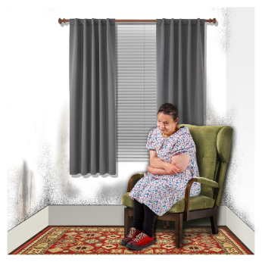
calling you names
neglecting you / not letting you have the things you need like food.

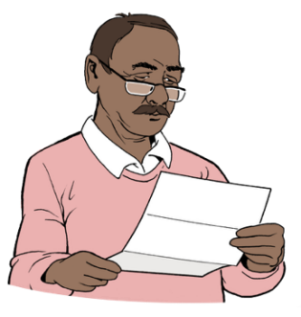
This pānui / notice is about redress.

Redress means someone:
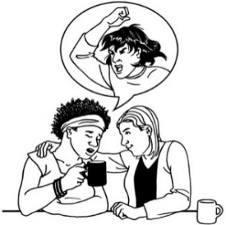
agrees that something bad has happened
does something that tries to:

- put things right
- make up for any harm that has been done.


Redress can be things like:
saying sorry
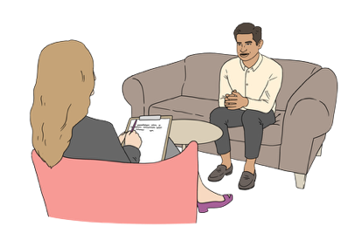
giving money to say sorry
giving support like counselling.

New redress service

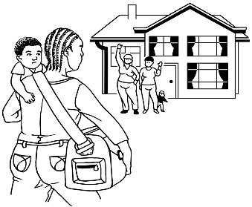
There is a new service for abuse survivors.

It is called the State redress service.


The State redress service is to make redress easier.

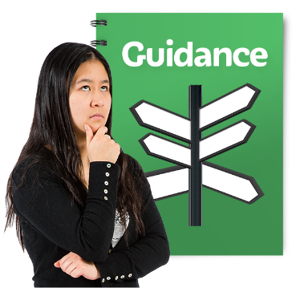
It means survivors only have to go to 1 place for support.

Some survivors have had to go to lots of different places to get support.


This can be confusing.


The State redress service will stop this from happening.

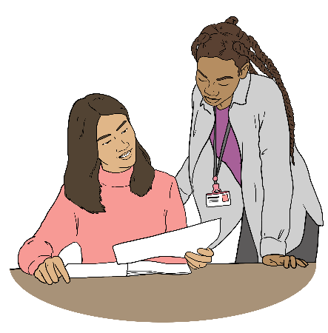
The State redress service will support people who:
were abused in more than one care service
have been dealing with more than one redress agency.


A care service is a place where people assist you to take care of yourself if you:
are disabled

are sick
are getting older
need help to stay safe.

A redress agency means a government agency that helps people get State redress.


The State redress service can:
answer questions about redress
support people to make a new claim

show people where to go for support
let people know what is happening with their claim

support people to find out about records from their time in care
help with wellbeing support
say what happens next.


Records mean the information an organisation has kept / made about a person.


Wellbeing means things like:
how we feel about ourselves

looking after our bodies with:
- good food
- exercise
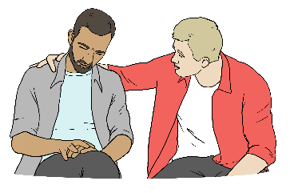
getting support when we are feeling upset.

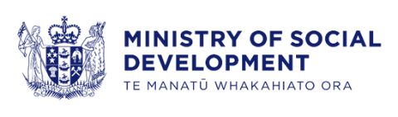
The Ministry of Social Development looks after the State redress service.


The Ministry of Social Development helps all the agencies involved in State redress:
work together
support survivors.



If you already have a redress claim:
you do not need to start again
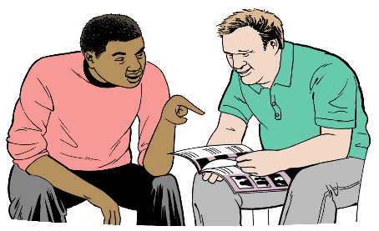
you will keep working with the same person at the redress agency.

Contacting the State redress service

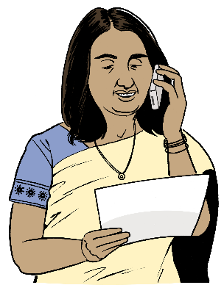
You can contact the State redress service to:
find out about State redress
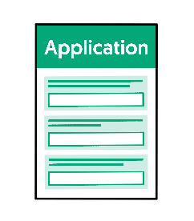
make a new claim
understand what happens next.


You can phone the State redress service on:

0800 110 886


It does not cost money to phone this number.


You can phone the State redress service from another country on:
+64 4 910 9886


It could cost you money to phone this number.


You can email the State redress service at:

contact@info.redress.govt.nz

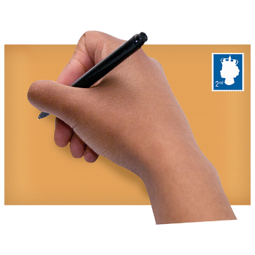
You can contact the State redress service by post at:

State redress service
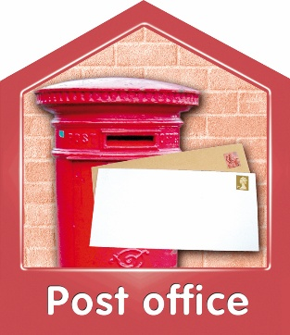
State Redress NZ

PO Box 1556

Wellington


6140

You can find out more about the State redress service at:

www.redress.govt.nz
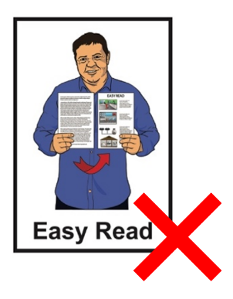
This website is not in Easy Read.

More information


You can share this pānui / newsletter if you want to.


People can sign up to get the
pānui / newsletter by email:
contact@abuseinquiryresponse.govt.nz

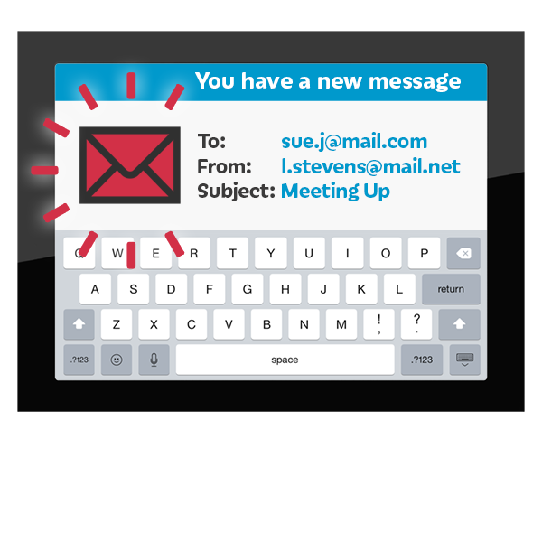
Please put Pānui Newsletter as the email subject.

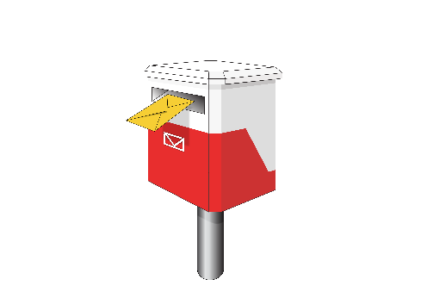
People can also sign up to get the newsletter by post:

Crown Response Office

Te Kawa Mataaho Public Service Commission

PO Box 329

Wellington 6140


If you do not want to be sent the pānui / newsletter you can write to the postal address above.

Other alternate formats of this
pānui / newsletter can be found at:

tinyurl.com/j444kpsa

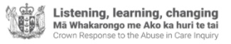
This information has been written by the Crown Response Office.

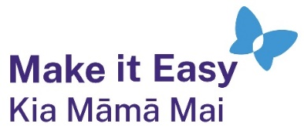
It has been translated into Easy Read by the Make it Easy Kia Māmā Mai service of People First New Zealand Ngā Tāngata Tuatahi.
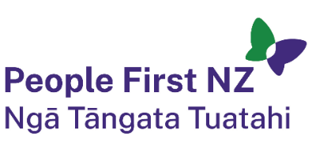
The ideas in this document are not the ideas of People First New Zealand Ngā Tāngata Tuatahi.

All images used in this Easy Read document are subject to copyright rules and cannot be used without permission.


Make it Easy uses images from:

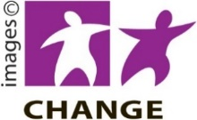
- Photosymbols

- Change Images


- Huriana Kopeke-Te Aho

- SGC Image Works

- T Wood


- Studio Rebeko

- Inga Kramer.

