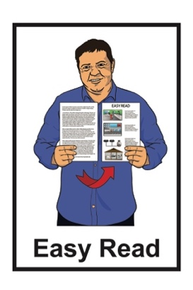
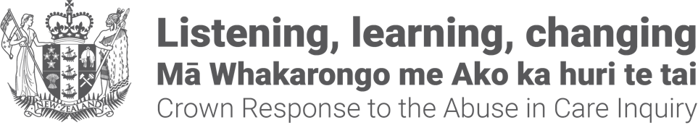

Crown Response Office
pānui / newsletter
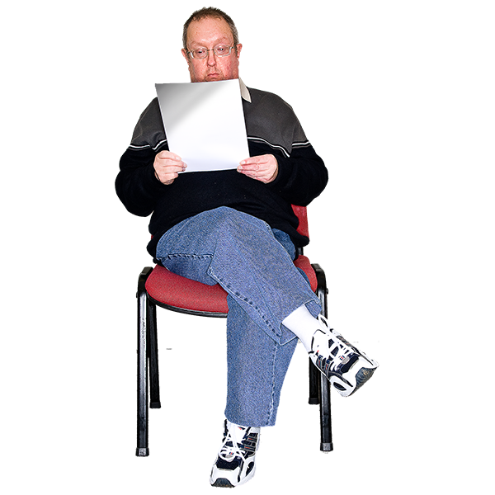

Published: August 2026

Before you begin


This Easy Read talks about abuse.

This information may upset some people when they are reading it.

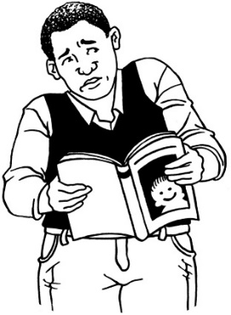

This information is not meant to scare anyone.

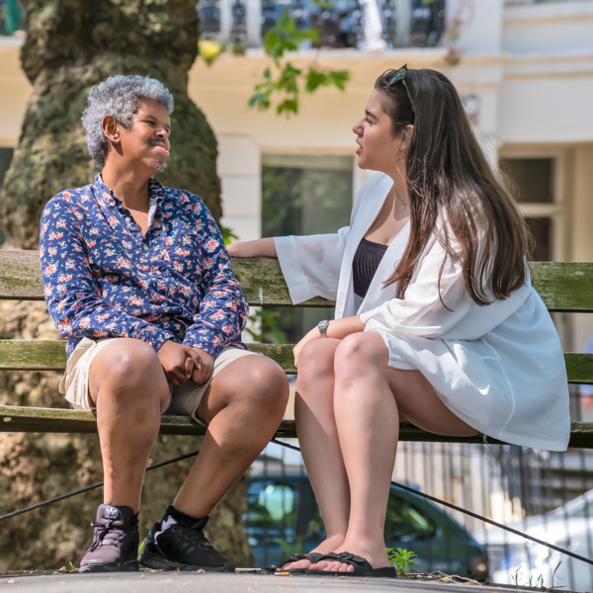
If you are upset after reading this document you can talk to your:
whānau / family
friends.

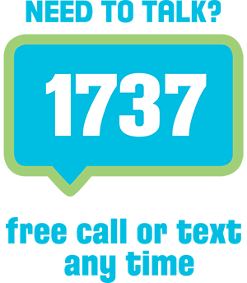
You can also contact Need to Talk by:
calling 1737
texting 1737


It does not cost any money to
call / text 1737.

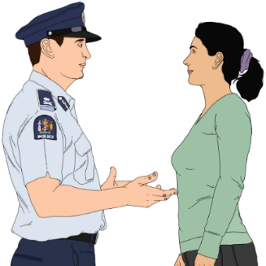
If you do not feel safe call the police on 111

About this Easy Read

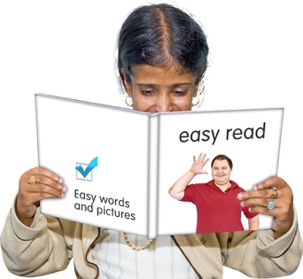
This Easy Read is a
pānui / newsletter from the Crown Response Office.


The Crown Response Office is in charge of the Government response to the Royal Commission of Inquiry into Abuse and Neglect in Care.

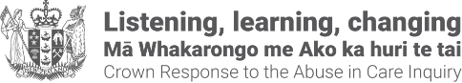
It is sometimes called the CRO.


Here response means what the Government is doing because of what the Royal Commission of Inquiry found out about the abuse and neglect of:
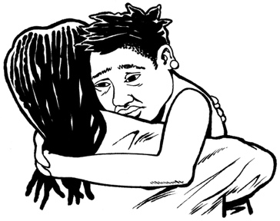
children
young people
vulnerable adults.

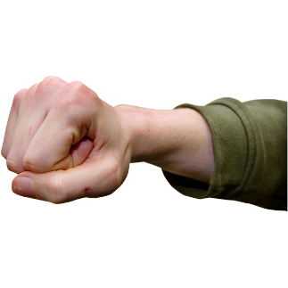
Abuse and neglect can be:
physical – a person kicking or hitting you
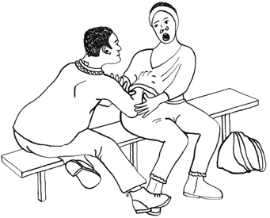
sexual – a person doing sexual things to you that you do not want them to like:
- touching your body or private parts
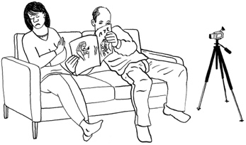
- kissing you
- making you have sex with them – this is called rape
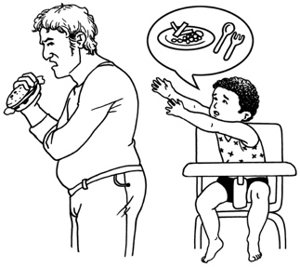
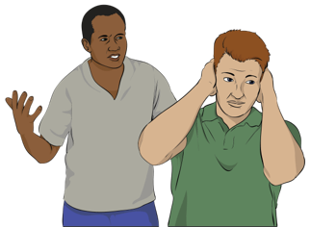
emotional – a person yelling or saying things to you that are not nice
a person not giving you the things or care that you need.

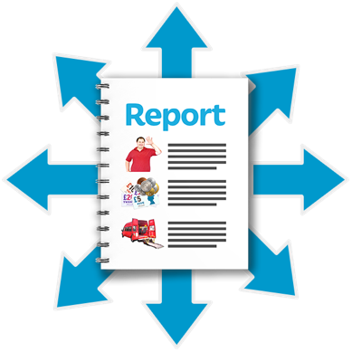
It has been 2 years since the Royal Commission of Inquiry put out its report into abuse in care.

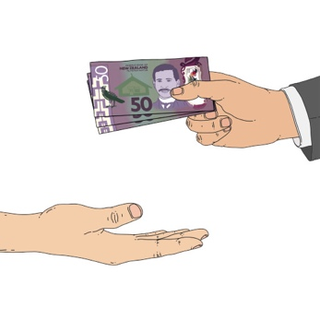
The report had recommendations for what the Government should do to:
make up for the harm that was done in the past
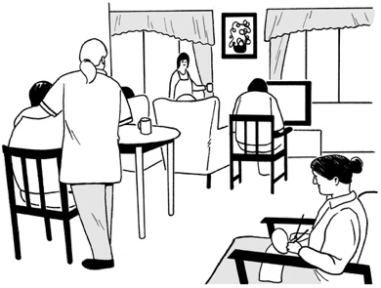
make being in care safer
give better support to people in care.


Here recommendations are ideas that would:
fix a problem
- make things better.

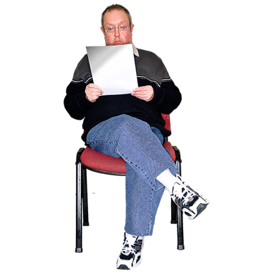
This pānui / newsletter has information about changes that are happening to the redress system.

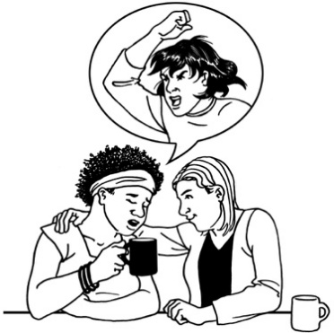
Redress means someone:
agrees that something bad has happened
does something to try to:

- put things right
- make up for any harm that has been done.


Redress can be things like:
saying sorry
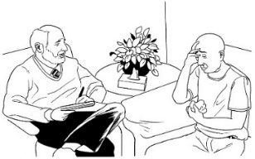
giving money as a way of saying sorry
giving other kinds of support like counselling.


You can read more CRO
pānui / newsletters at this website:

https://tinyurl.com/25mt2z4n

Changes coming to the redress system

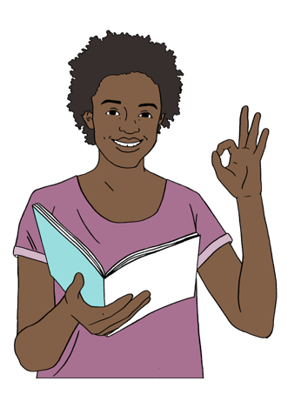
The redress system is going to change soon so it will be easier to:
understand
use.
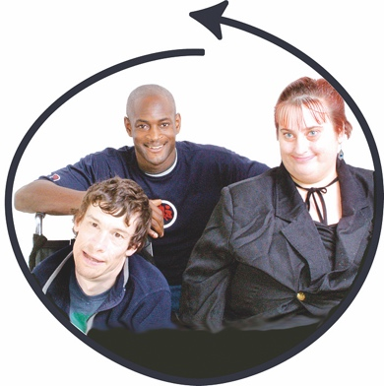

These changes will make it so the way to make a claim is the same for everyone.

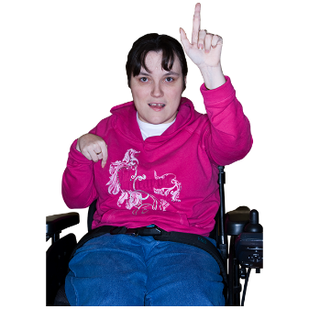
Here claim means asking the Government for redress.

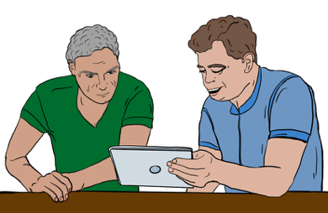
There will be 1 place to go for information about:
redress
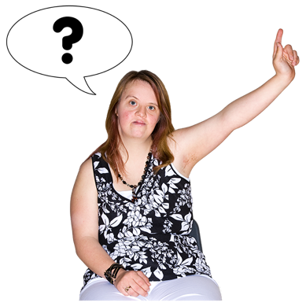
making a claim
finding out what is happening with a claim.

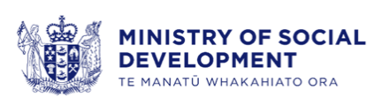
The redress service will now be part of the Ministry of Social Development.

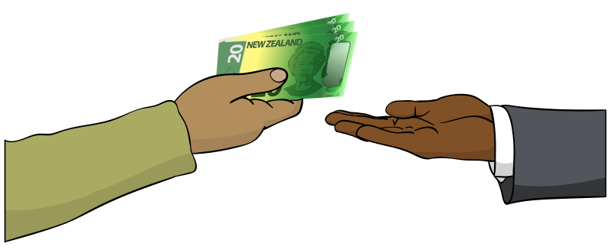
The Ministry of Social Development is the part of the Government in charge of:

paying benefits / money to people who do not have
enough money to live on
supporting people to find jobs.

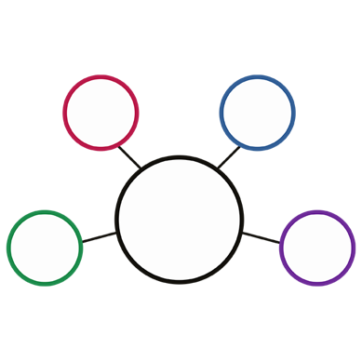
Having all the parts of the redress service in 1 place means survivors will not have to:
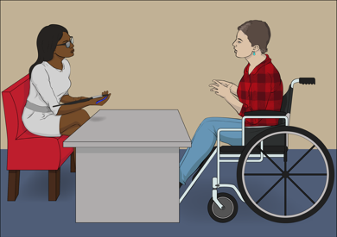
deal with a lot of agencies
keep telling new people about what they have been through.

Some survivors have had experiences with more than 1:
state care setting / place
Government agency.


These changes will mean different Government agencies will work together better to sort out claims about more than 1 agency.

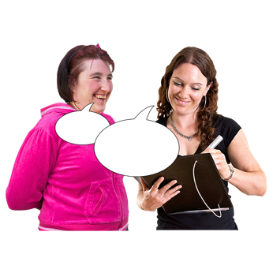
There will also be changes to how information from survivors is:
collected
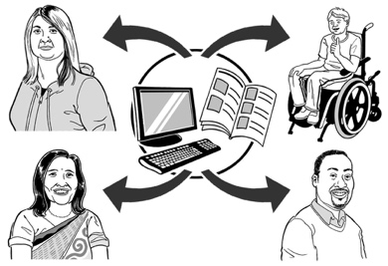
used
shared.

This will make it easier for different parts of the redress system to work together.

These changes are only for new claims.


If you have already made a claim you do not need to do anything.


There is more information about the changes to the redress system on this website:

https://tinyurl.com/4u84zhh7
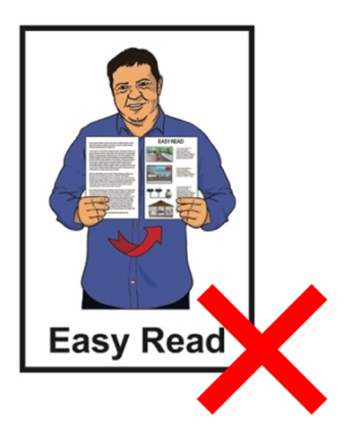

The website is not in Easy Read.

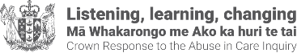
This information has been written by the Crown Response Office.

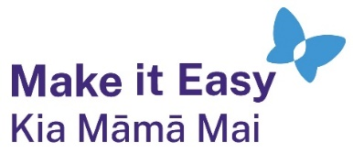
It has been translated into Easy Read by the Make it Easy Kia Māmā Mai service of People First New Zealand Ngā Tāngata Tuatahi.
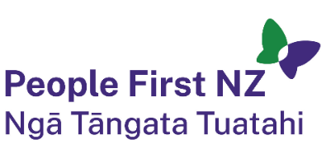
The ideas in this document are not the ideas of People First New Zealand Ngā Tāngata Tuatahi.

All images used in this Easy Read document are subject to copyright rules and cannot be used without permission.


Make it Easy uses images from:

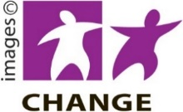
- Photosymbols

- Change Images


- Huriana Kopeke-Te Aho

- SGC Image Works

- T Wood

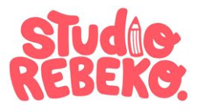
- Studio Rebeko

- Inga Kramer.

