
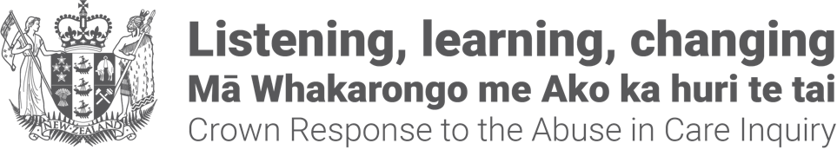

Crown Response Office
pānui / newsletter


Published: August 2026

Before you begin


This Easy Read talks about abuse.

This information may upset some people when they are reading it.



This information is not meant to scare anyone.


If you are upset after reading this document you can talk to your:
whānau / family
friends.

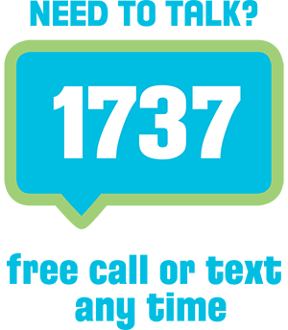
You can also contact Need to Talk by:
calling 1737
texting 1737


It does not cost any money to
call / text 1737.


If you do not feel safe call the police on 111.

What is in here

Page number:


About this Easy Read 4


Supporting the care workforce
to work more safely 9

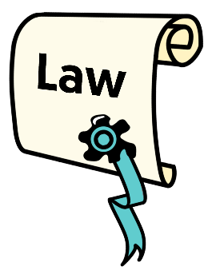
A new law about redress
for abuse in care 17


About the Redress Officer 22


More information 27

About this Easy Read


This Easy Read is the latest
pānui / newsletter from the Crown Response Office.


The Crown Response Office is in charge of the Government response to the Royal Commission of Inquiry into Abuse and Neglect in Care.

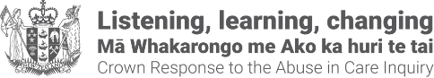
It is sometimes called the CRO.


Here response means what the Government is doing because of what the Royal Commission of Inquiry found out about the abuse and neglect of:

children
young people
vulnerable adults.
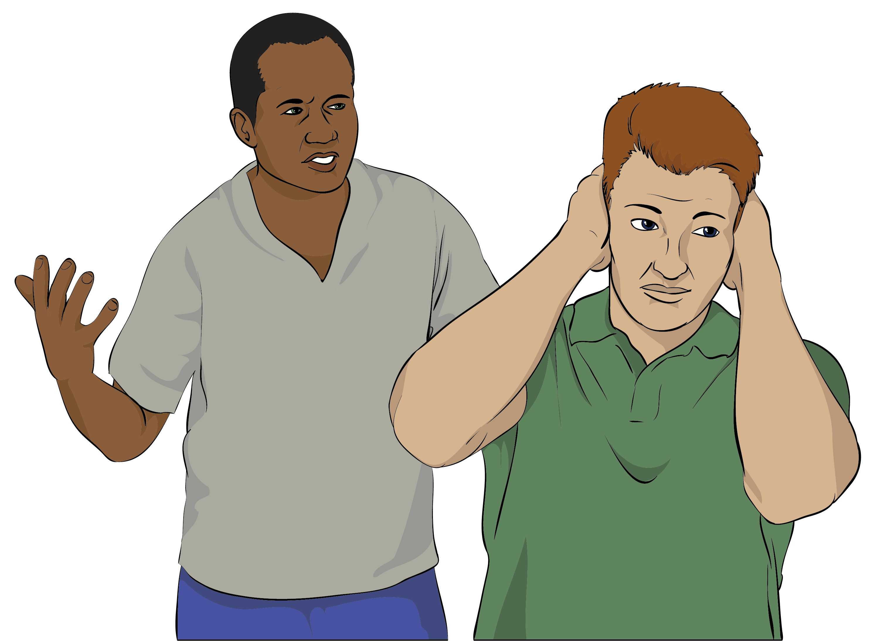
Abuse can be things like someone:
hitting you
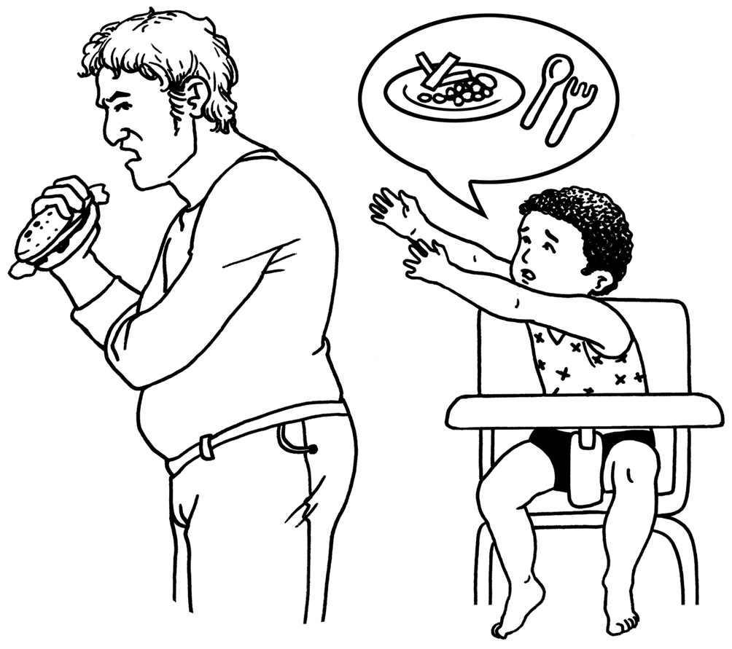
calling you names
neglect / not letting you have the things you need like food.


It has been 2 years since the Royal Commission of Inquiry put out its report into abuse in care.


The report had recommendations for what the Government should do to:
make up for the harm that was done in the past
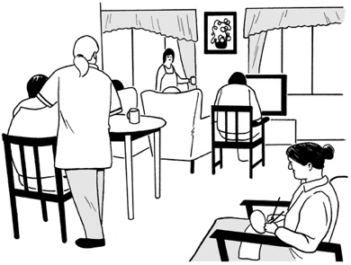
make being in care safer
give better support to people in care.

Here recommendations are ideas that would:
fix a problem
- make things better.


This pānui / newsletter has information about the latest changes happening to make the redress system better.

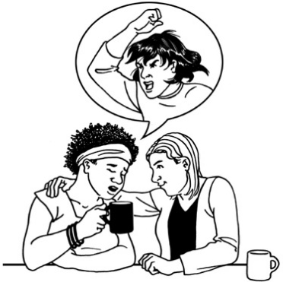
Redress means someone:
agrees that something bad has happened
does something to try to:

- put things right
- make up for any harm that has been done.


Redress can be things like:
saying sorry
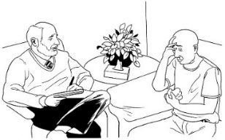
giving money as a way of saying sorry
giving other kinds of support like counselling.


You can read more CRO
pānui / newsletters at this website:

https://tinyurl.com/25mt2z4n

Supporting the care workforce to
work more safely

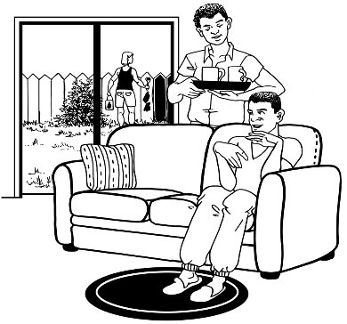
Here care workforce means people working in places that provide:
care for people
support for people.



The Royal Commission found that the care workforce needs better safeguarding skills.


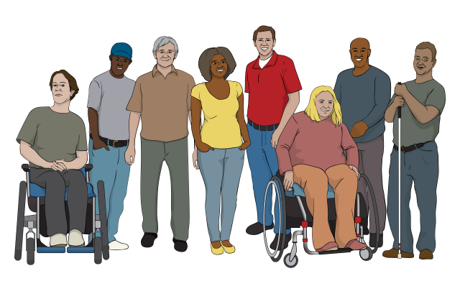
Here safeguarding means keeping people safe from:
abuse
neglect.

The Government wants to make the care system safer.

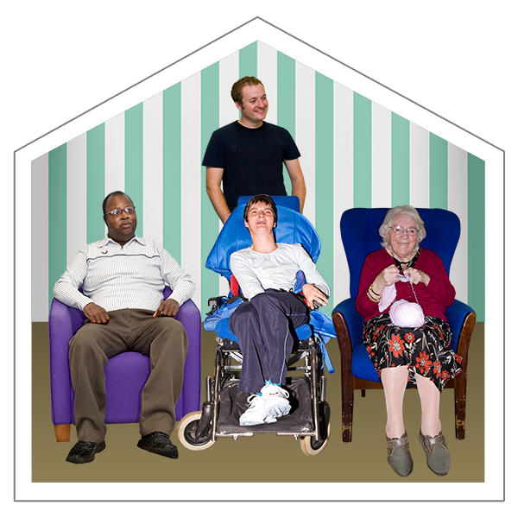
Having a care workforce with better safeguarding skills will support people using the care system to be safe.

The Government has said yes to pay for the care workforce to have more training to support them to provide / give care for people in a safe way.



It will pay nearly 17 million dollars for this work over 3 years.


The money will come from the Government Budget for 2025.



Here the Budget is when the Government says:
how much money it will spend in the coming year
what it will spend the money on.


This work will support:
the care workforce
organisations that provide care to support people in safer ways.

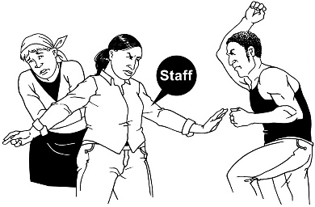
The money will support the care workforce to:
stop abuse or neglect happening

notice when abuse or neglect might be happening
do something if abuse or neglect is happening.


Some of this safeguarding work will be about disability:
care
support services.


This is the first use of Government funding / money to build a care workforce that is:

diverse

skilled
safe.

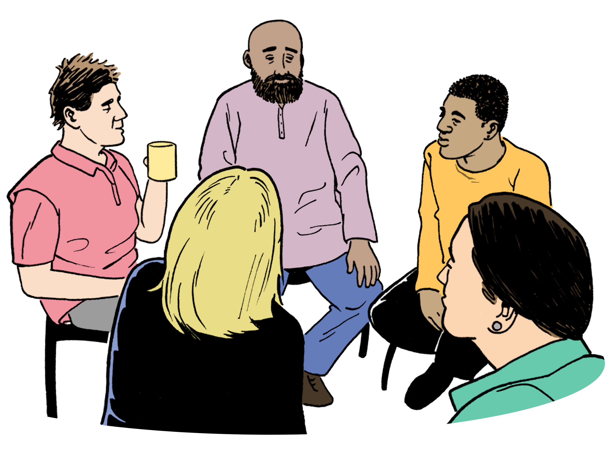
Diverse means the workforce includes people with different:
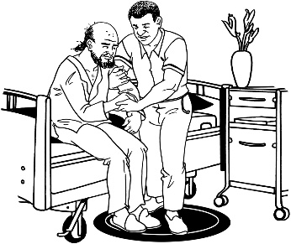
backgrounds
cultures
experiences.

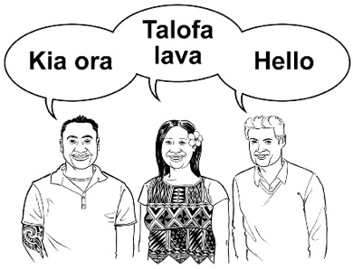
Culture is a way of:
thinking that a group shares
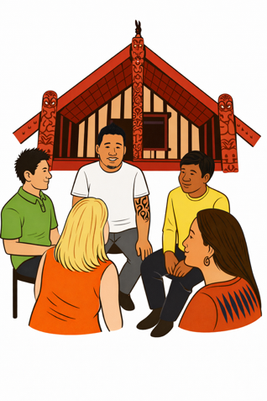
doing things as a group.

There are many different cultures in
Aotearoa New Zealand like:
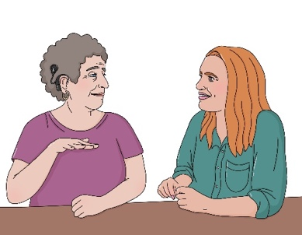
Māori culture
Pasifika culture
Deaf culture.


Work on these projects will start this year.


A safeguarding framework / set of rules for the care workforce will also be made.


The framework / set of rules will explain the safeguarding skills care workers need.


A survey will also be made to find out what skills the care workforce have now.

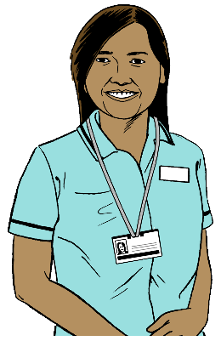

Here a survey asks questions to find out information about something.


The surveys will be used to:
find out:
what is happening now

watch how things change over time.

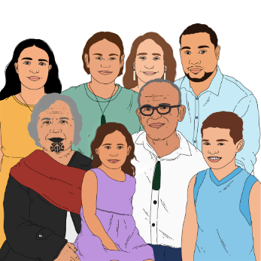
Safeguarding resources will also be made to support:
whānau / family carers of disabled people

disabled people who receive care
disability care workers
disability support workers.


Here resources means information to support people to find out what they need to know for safeguarding.


Doing this work will support workers in the care sector by training them to work in a more consistent way.


Here consistent means people will do things in a similar way.


It will also support the care workforce to:
recognise abuse or neglect
do something to stop abuse or neglect if they see it happening.


Here recognise means to
notice / tell what is happening.

You can read more about the Government work to make the care system safer at this website:

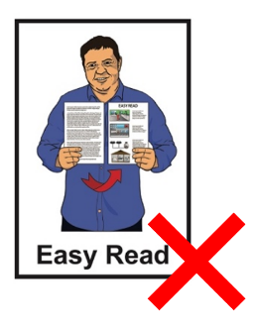
https://tinyurl.com/mn6btynr

This website is not in Easy Read.

A new law about redress for abuse in care


The Redress System for Abuse in Care Act 2026 has been passed in Parliament.

This means it is now a law.

A law is a rule made by the Government that everyone must follow.


The new law supports changes to the redress system.


1 main change is making a new Redress Officer role / job.


The Redress Officer will be independent.



Here independent means the Redress Officer will not be told what to do by the Government.

There is more information about the Redress Officer on pages 22 to 26.


This law also supports apologies from the State to be more
meaningful / real.


More survivors will be able to ask for redress like some who experienced abuse in mental health places.


This abuse must have happened between:
1 July 1993


and
30 June 2022.

The law also sets out a new serious offender process.

A serious offender is someone who has done something very bad to break the law.


This process applies to survivors who have been convicted of some serious offences like:
being violent
sexual offences.

Convicted means a court has decided that an offender has been found to have broken the law.
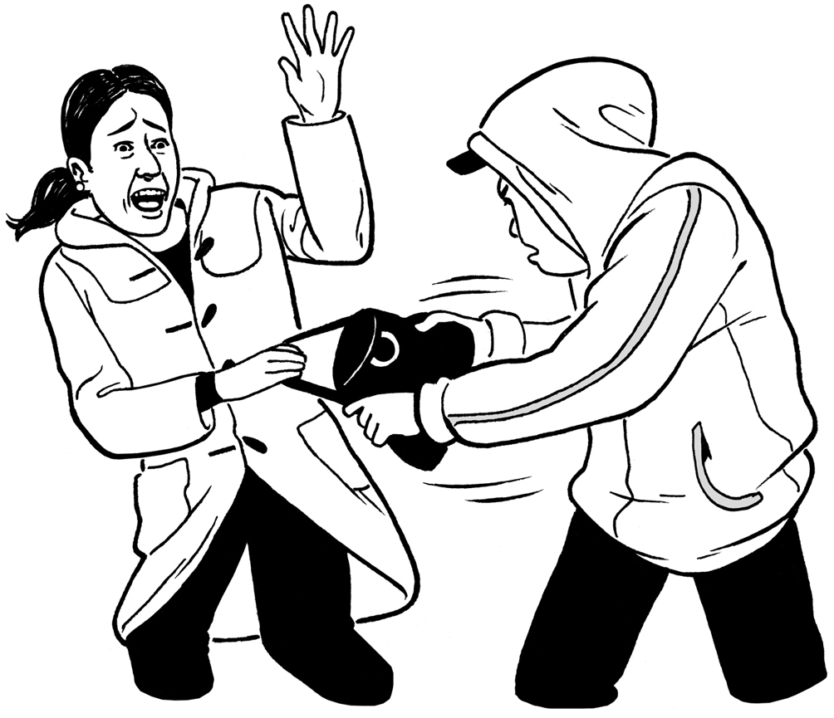

An offence is when someone has done something to break the law.

Violent means that someone has done something very bad like badly:
hurt someone
damaged / broken something.

The changes will work to make the redress system more:
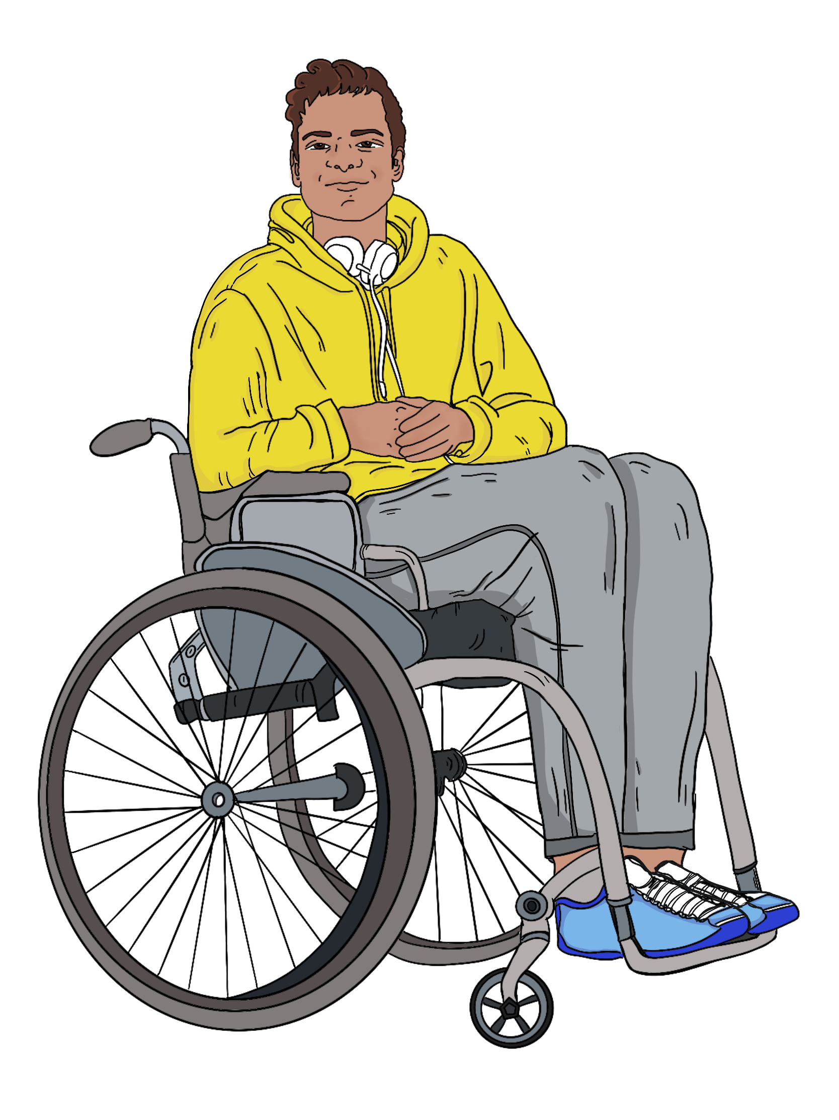
consistent
complete / does everything that needs to be done
about what survivors need.

You can read more about this law at this website:


https://tinyurl.com/bcfpa3bf

This website is not in Easy Read.

About the Redress Officer role

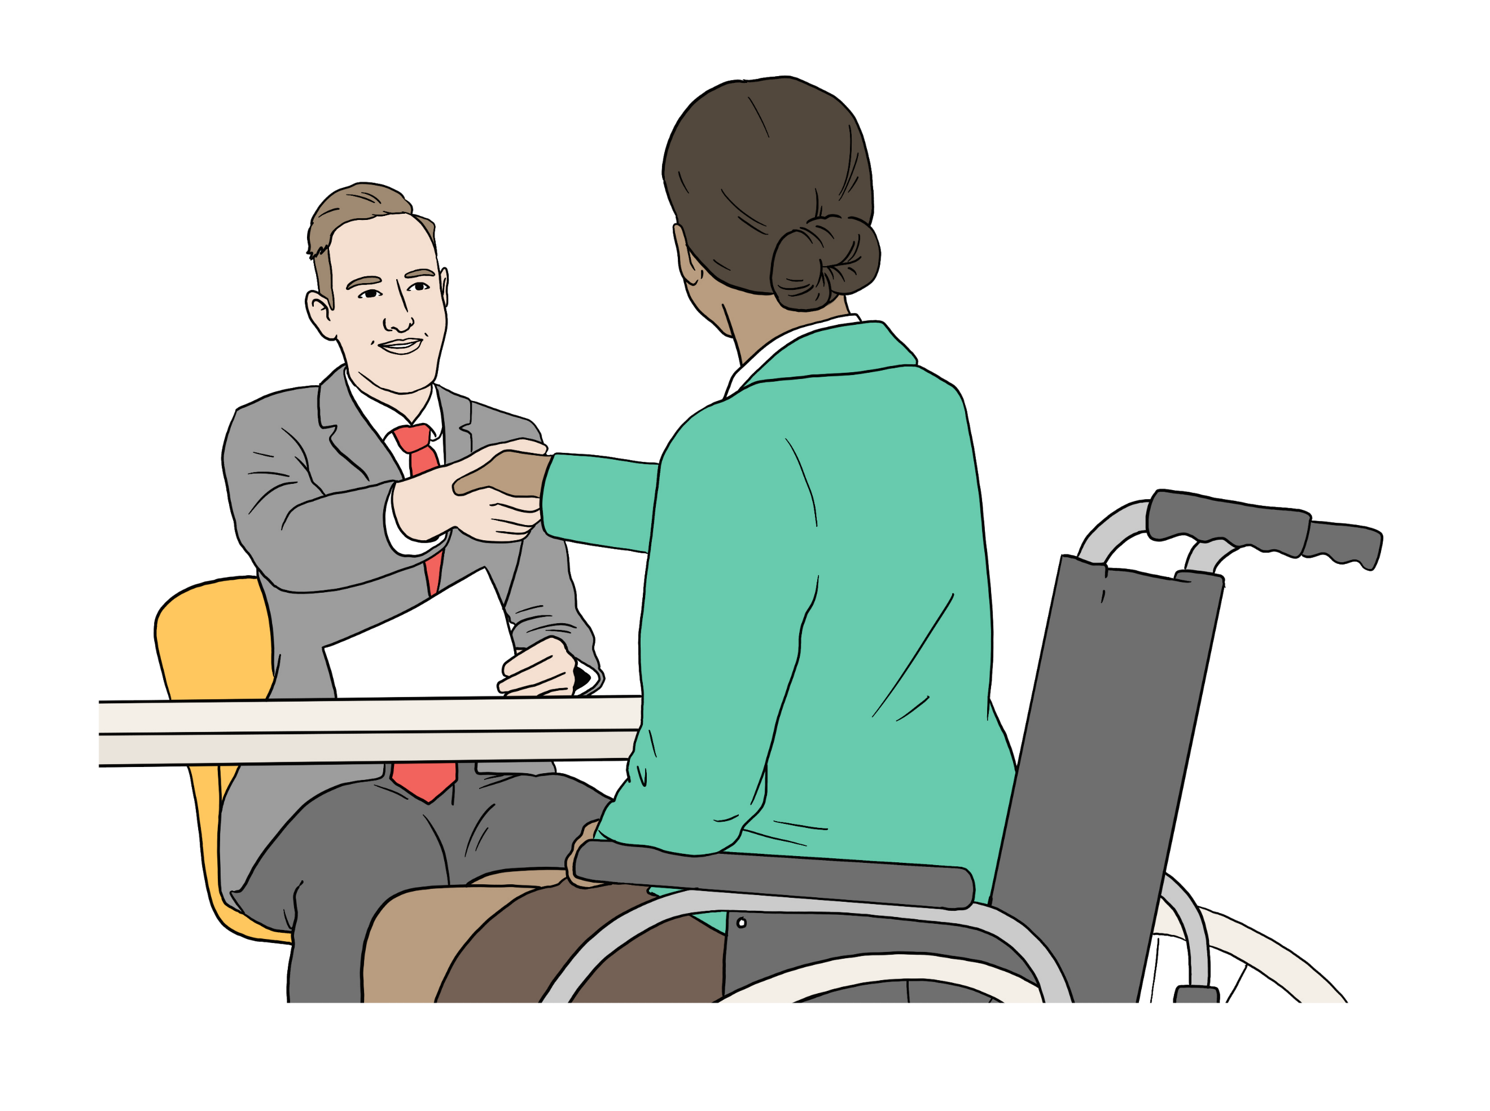
A new role / job called the Independent Redress Officer has been made to support making redress better.

This role / job plays an important part in keeping people safe when using the State redress system.

It will make sure any payments made to survivors are fair.



This is so people will not think badly of the redress system.


Honourable Paul Davison has been made the first Redress Officer in
New Zealand.

He was a judge who worked on the Lake Alice redress.


He will be the Redress Officer for
5 years.



His term / job started on 1 August 2026.


The Redress Officer is a statutory decision-maker.

A statutory decision-maker is someone who has the legal power to make some important decisions.

Legal means things to do with the law.

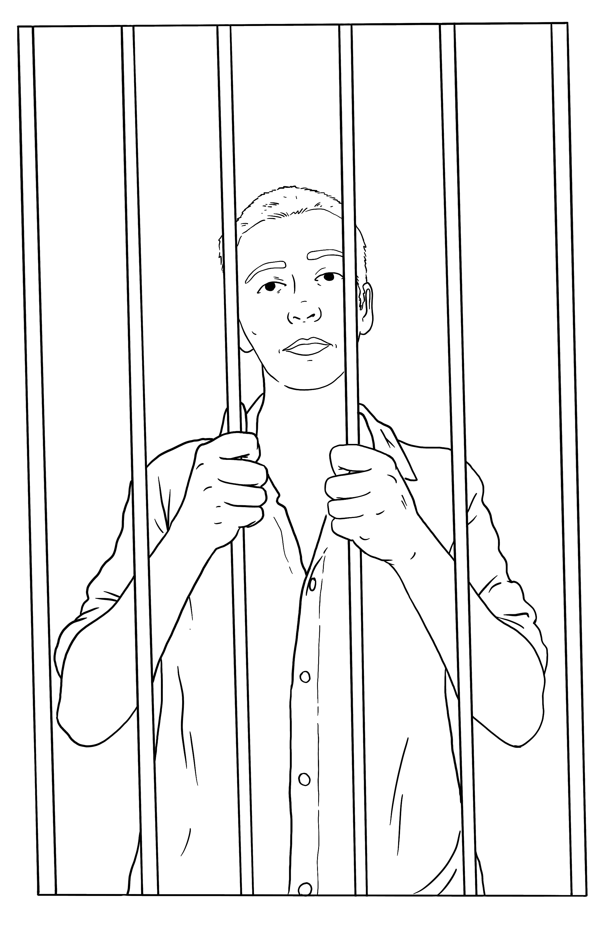
What the Redress Officer will do

Some survivors have
committed / done a serious offence.


This means they will have to follow the rules about serious offenders in the new law.


A survivor who has committed / done a serious offence can ask the Redress Officer if they can get redress.


The Redress Officer will look at each application carefully to see if the survivor should get redress.

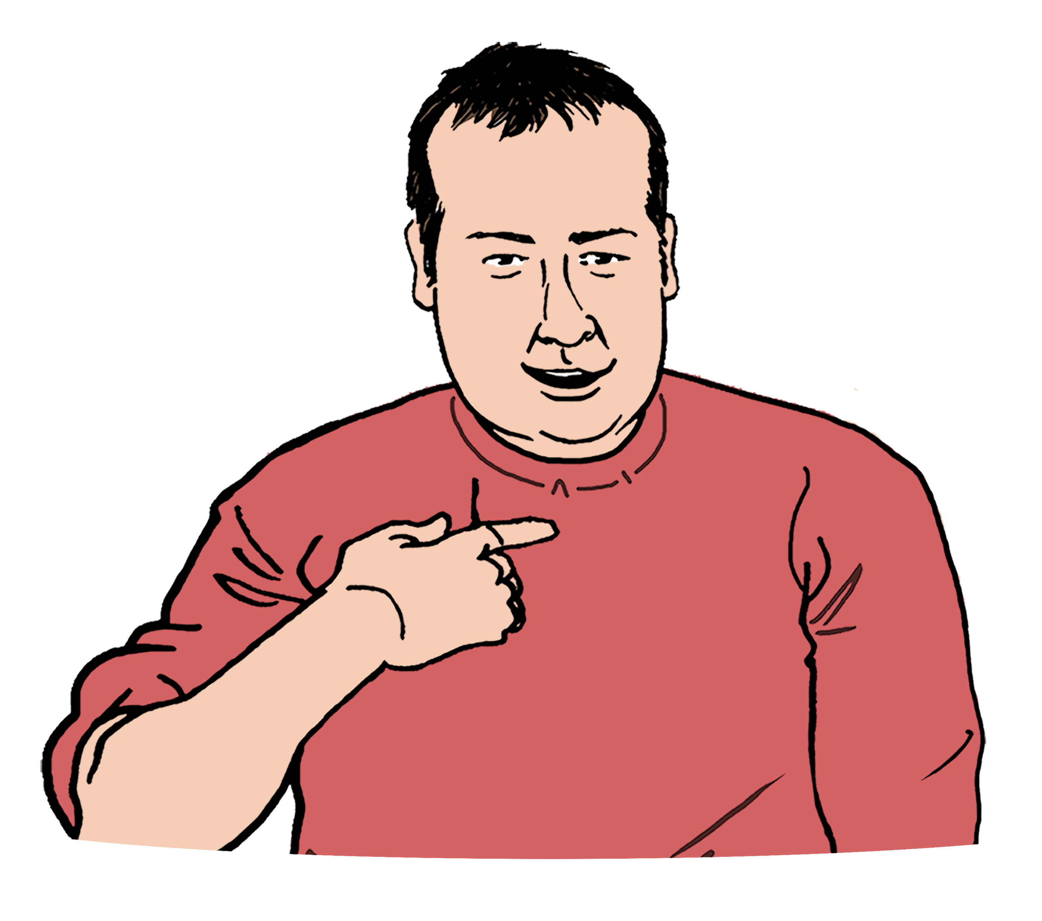
Here application means a person has asked for something.


The Redress Officer can decide if they:
will get redress
will not get redress.

The Redress Officer will decide if the survivor can get financial / money redress.

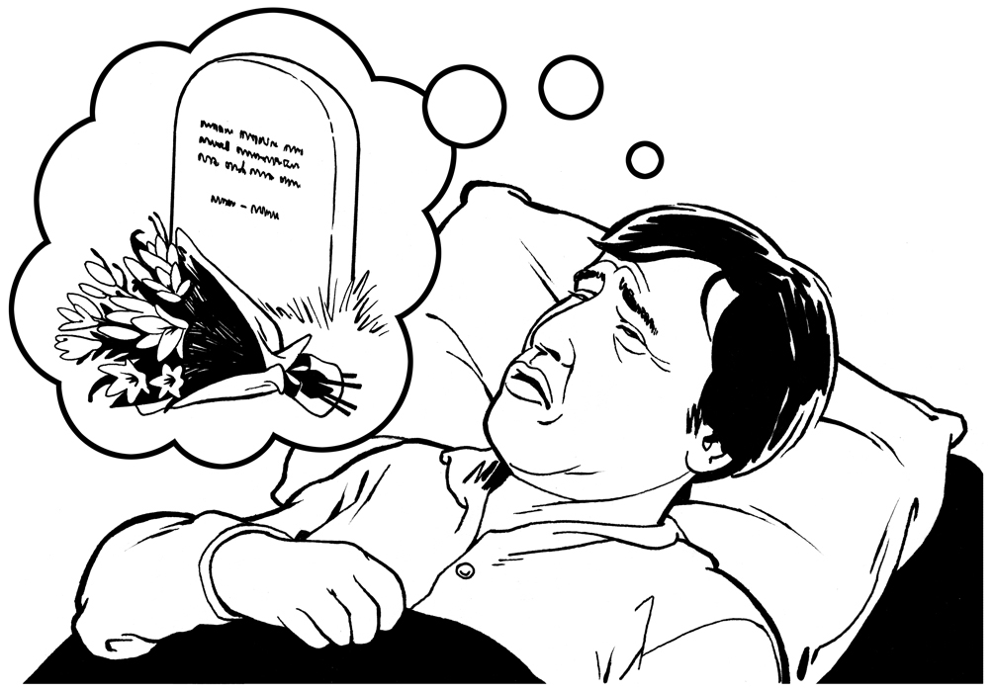
Some serious offender survivors may have an advanced terminal illness.
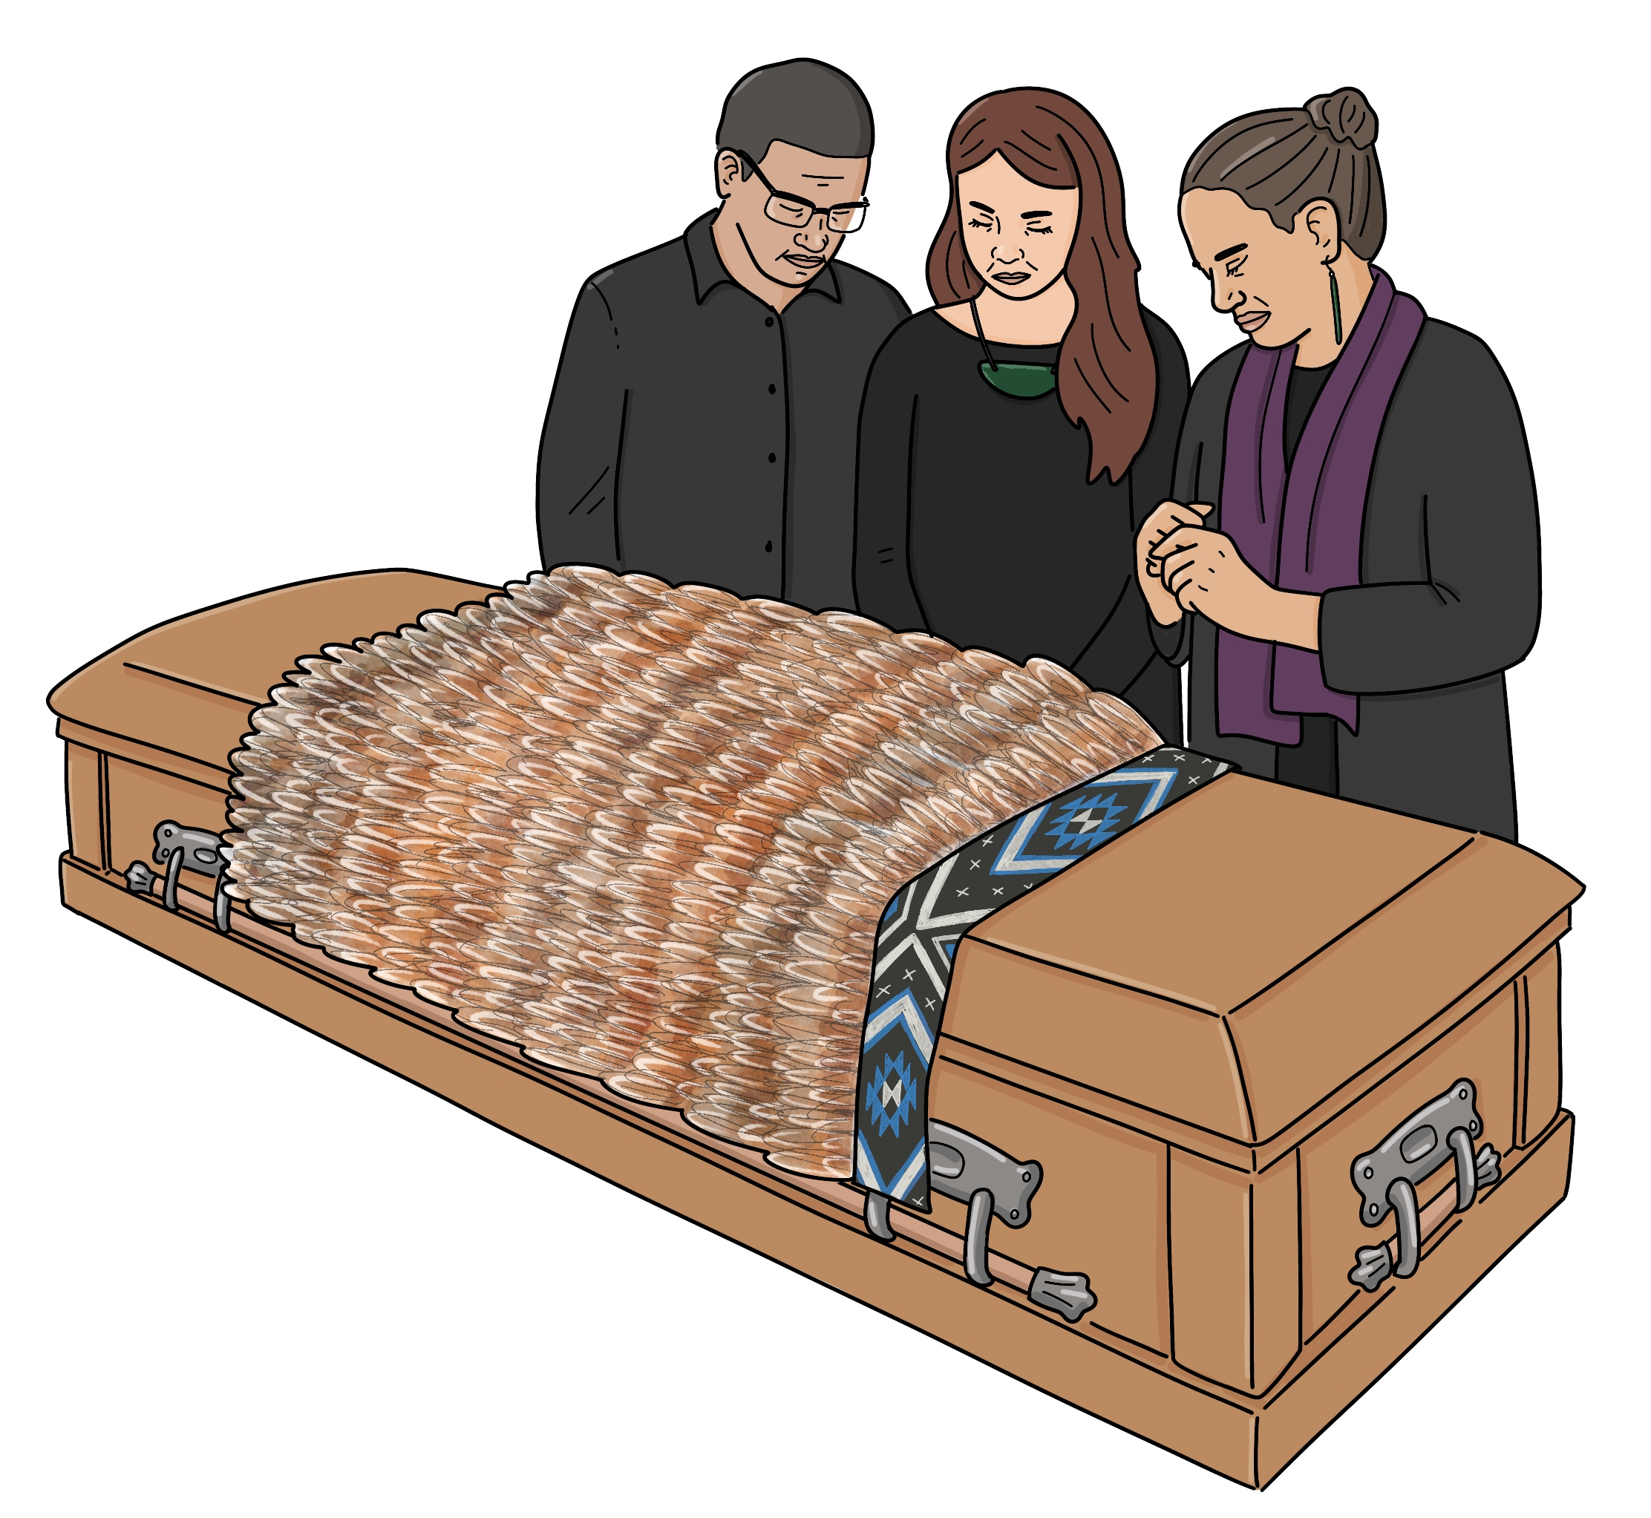
An advanced terminal illness is a very bad illness where a person is likely to die soon.

These survivors can ask for an exemption from the serious offender process.

Here an exemption means the person will not have to go through the serious offender process.


The Redress Officer will make a decision about each exemption application he gets.

You can find out more about the Redress Officer at this website:

https://tinyurl.com/53ex8nk8

This website is not in Easy Read.

More information


There is more information about the changes to the redress system on this website:

https://tinyurl.com/4u84zhh7


The website is not in Easy Read.


This information has been written by the Crown Response Office.


It has been translated into Easy Read by the Make it Easy Kia Māmā Mai service of People First New Zealand Ngā Tāngata Tuatahi.

The ideas in this document are not the ideas of People First New Zealand Ngā Tāngata Tuatahi.

All images used in this Easy Read document are subject to copyright rules and cannot be used without permission.


Make it Easy uses images from:


- Photosymbols

- Change Images


- Huriana Kopeke-Te Aho

- SGC Image Works

- T Wood


- Studio Rebeko

- Inga Kramer.

