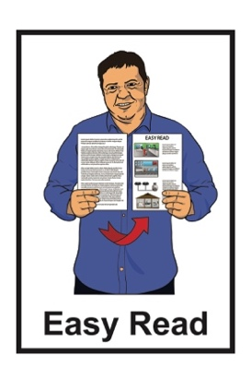

Cabinet paper summary:

Terms of Reference for

Design and Advisory Groups

Published: June 2023

# What is this document about?



This document is an Easy Read **summary** of a **Cabinet Paper**.

A **summary** is:

shorter than the full report

tells you the main ideas.

A **Cabinet Paper** has information in it that **Cabinet** needs to:

know

make a decision about.

**Cabinet** is a group of people called Ministers who work in Government.

These Ministers meet to make important political decisions.

The Cabinet Paper is from Andrew Little who is the Minister for the Public Service.

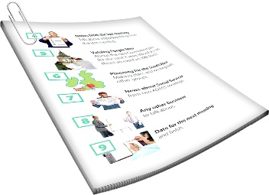The Cabinet Paper is about the **Terms of Reference** that will be used by **Design and Advisory Groups**.

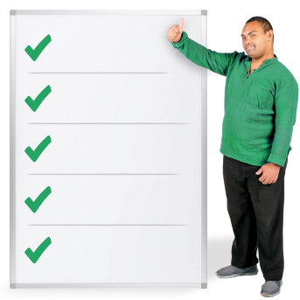

**Terms of Reference** are the things the group work on.

The **Design and Advisory Groups** are groups of people who have been asked to make a **redress** system for people who were abused while in care.

We will explain what the word **redress** means on **pages 9 to 12** of this document.

You can find the full Cabinet Paper at:

**https://bit.ly/3qshlaR**



****The full Cabinet Paper is **not** in Easy Read.

You can find more Easy Read information about the Crown Response to the Abuse in Care Inquiry at this **website** link:

**https://bit.ly/3qFqU6l**

# Changes to the Terms of Reference

The Government needs to create a redress system very quickly.

It is important that the Terms of Reference can be used well by the Design and Advisory Groups.

The Terms of Reference might need to be changed if anything new happens like:

the amount of time we have to create the redress system changes

the way we need to present the proposals changes.

The **Cabinet Social Wellbeing Committee** is being asked to allow the Minister for the Public service to change the Terms if needed.

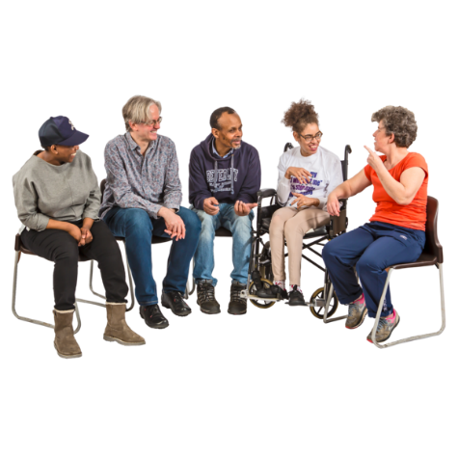

The **Cabinet Social Wellbeing Committee** thinks about plans to make sure everyone has a good **standard of living**.

It is also called the **SWC**.

**Standard of living** means things like:

having enough money to buy the things you need to have a good life

having enough food to eat.

It is important that the Design and Advisory Groups are well supported so that they can:

do what they planned to do

create a safe place to work

create a **trauma-informed workspace.**

A **trauma-informed workspace** is somewhere that people can work while feeling:

safe

listened to

understood.

The Design and Advisory Groups will have a lot of services to support them in their work.

# What is a redress system?

**Redress** means someone:

agrees that something bad has happened

does something to try to:

* put things right
* make up for any harm that has been done.

Redress can be things like:

saying sorry

giving money as a way of saying sorry

giving other kinds of support like counselling.

The redress system this paper is about is for people who were **abused** while **living in** **care**.

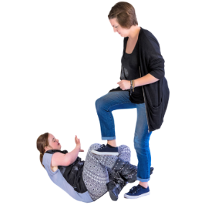

Being **abused** means experiencing things like:

* A picture containing sketch, drawing, line art, footwear

  Description automatically generated**physical** **abuse** such as a person kicking / hitting you
* **sexual** **abuse** such as a person doing sexual things to you that you do not want them to

* 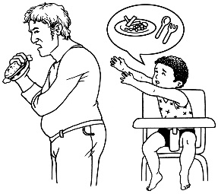**emotional** **abuse** such as a person yelling or saying things to you that are not nice
* **neglect** such as a person not giving you the things / care you need.

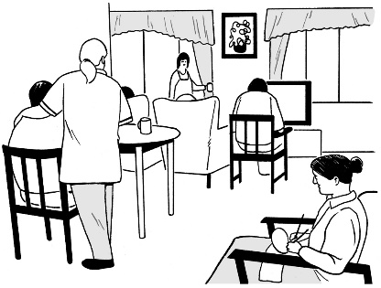**Living** **in care** means that the Government or a **faith-based institution** was in charge of your care / looking after you.

**Faith-based institutions** are run by religious groups like churches.

Cabinet has already said yes to making a new redress system that is:

* not part of the Government
* focused on **survivors**.

In this documentwe call people who have been though abuse in care **survivors**.

Cabinet has also said yes to some projects to make the way redress happens now better for survivors.

It is important to work out the best way for the new redress system to work.

**Terms of Reference**



The Cabinet Paper says what the **Terms of Reference** for the Design and Advisory Groups might be.

The Design and Advisory Groups need to say that they are happy with these Terms of Reference.

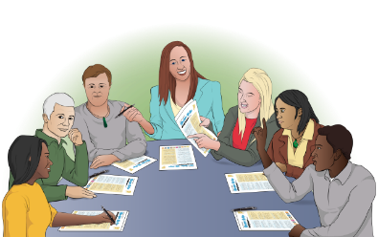

The Terms of Reference will support the Design and Advisory Groups to:

* A person giving a thumbs up

  Description automatically generated with low confidencedo what they need to do
* make sure any risks are managed in a safe way.

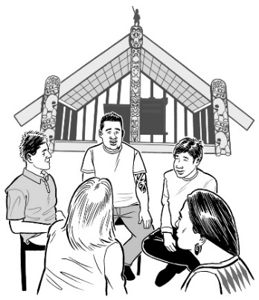The Terms of Reference make it so the Design and Advisory Groups can:

* have Māori as leaders
* 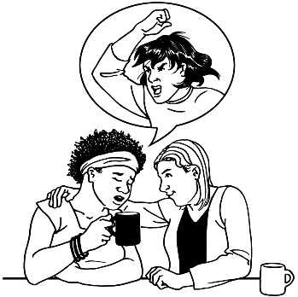have a lot of different ways of looking at things from different groups of survivors
* A person looking at his watch

  Description automatically generatedcreate plans for the work they will do to be:
* safe
* on time.

The Terms of Reference say:

* what the different roles in the groups are
* A black and white drawing of men shaking hands

  Description automatically generated with low confidencewhat each person needs to do
* A book with check marks and green tick

  Description automatically generated with low confidencehow the Design and Advisory Groups will work
* the rules for making choices
* the rules for fixing problems.

Some of the Terms of Reference are:

* A person pointing to the side

  Description automatically generated with low confidencethe Design Group will lead the work
* the Advisory Groups will support the Design Group in:
* A person in a wheelchair with a question mark

  Description automatically generated with low confidencereaching their goals
* telling the Design Group what survivors think of their ideas.

the Design and Advisory Groups will follow **Te Tiriti o Waitangi** / **The Treaty of Waitangi** as part of the new redress system.

**Te Tiriti o Waitangi / The Treaty of Waitangi** is a document that tells us how Government and Māori will work together to:

make decisions

protect things that are important to Māori.

The Design Group will meet in either:

* A green and white calendar with numbers

  Description automatically generated with low confidenceA picture containing text, metalware, lock, font

  Description automatically generatedlate May 2023

or

* early June 2023.

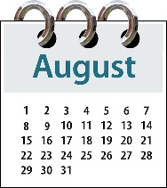

They will present their final plan in August 2023.

The Minister for the Public Service will have a **commissioning conversation** with the Design and Advisory Groups to:

* support them to start well
* make sure they know what needs to be in their plans.

A **commissioning conversation** is when the Minister for the Public Service talks with the Design and Advisory Groups to:

make it clear what the work is about

plan how to start the work.

Other Ministers can say if they would like to come to the commissioning conversation.

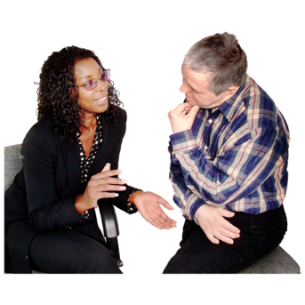The **Co-chairs** will be told if any other Ministers want to come along.

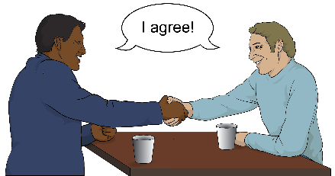A **Co-chair** is someone who works with someone else to lead the Design and Advisory Groups in making a redress system.

# Cabinet Paper recommendations

**Recommendations** are things that the Minister for the Public Service thinks should happen.

The recommendations are from the Minister for the Public Service to the SWC.

The Minister for the Public Service recommends that SWC says yes to:

* the Terms of Reference for the Design and Advisory Groups
* the Minister for the Public Service being allowed to make any changes to the Terms of Reference if he needs to do so.

The Minister for the Public Service also recommends that SWC says yes to:

* 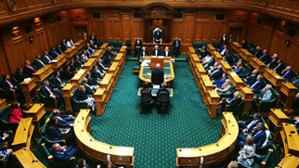other Ministers can ask to come to the commissioning conversation with the Design and Advisory Groups.

This information has been written by the New Zealand Government.

It has been translated into Easy Read by the Make it Easy Kia Māmā Mai service of People First New Zealand Ngā Tāngata Tuatahi.

The ideas in this document are not the ideas of People First New Zealand Ngā Tāngata Tuatahi.

Change logo.
Change is the name of the organisation.

Make it Easy uses images from:

* Changepeople.org



* Photosymbols.com

* SGC Image Works
* Huriana Kopeke-Te Aho.

All images used in this Easy Read document are subject to copyright rules and cannot be used without permission.