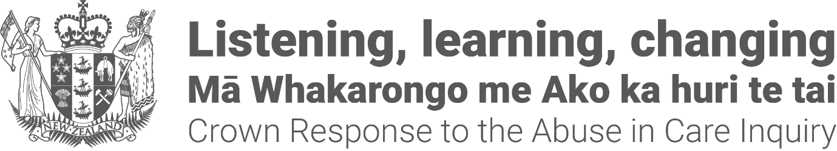

Crown Response to the

Abuse in Care Inquiry:

A statement from the

Co-chairs of the Redress Design Group
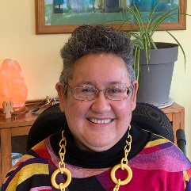

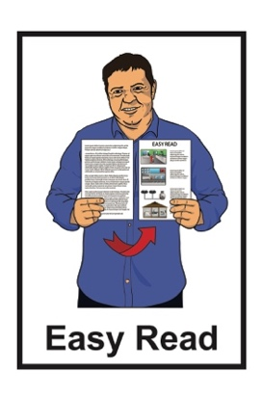

April 2023

About this newsletter

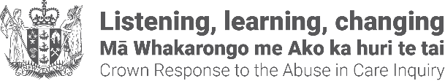
This Easy Read document is from the Crown Response to the Abuse in Care Inquiry.

It is a statement from the 2 new Co-chairs of the Redress Design Group.

We will explain what these things mean in the next parts of this document.

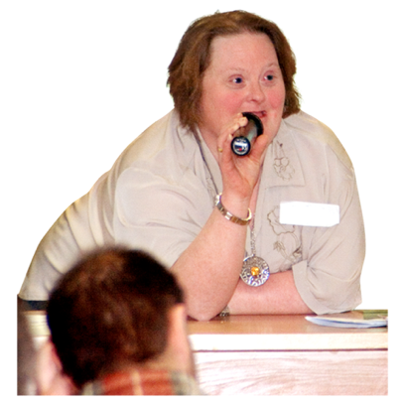
A statement is an official way of sharing:
what someone thinks
what someone will do.
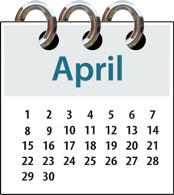
This statement is from 17 April 2023.

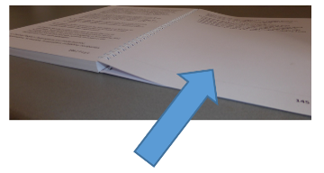
You can find the statement on
pages 13 to 17 of this document.

Some of the information in this document may upset people when they are reading it.

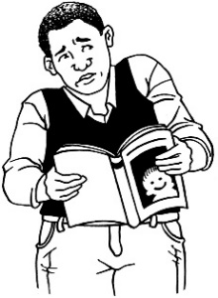
This information is not meant to upset anyone.

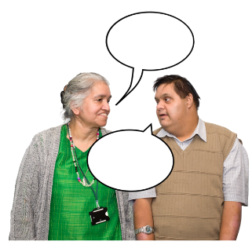
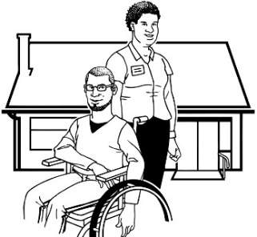
If you are worried or concerned after reading this you can talk about it with:
your family / friends
your support workers.

What is the Royal Commission of

Inquiry into Abuse in Care?

The Royal Commission of Inquiry into Abuse in Care is looking into abuse that happened to people
in care.

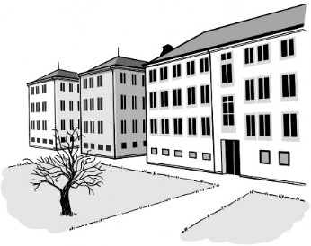
In this document being in care means that the Government or a faith-based institution was in charge of your care.

Faith-based institutions are run by religious groups like churches.

Abuse can be:
- physical – a person kicking or hitting you
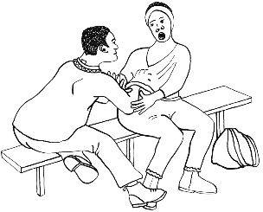
- sexual – a person doing sexual things to you that you do not want them to like:
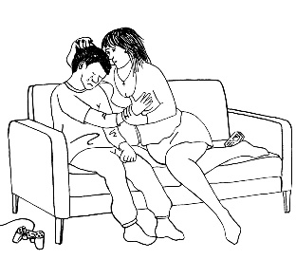
- touching your body or private parts
- kissing you
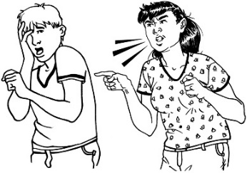
- making you have sex with them – this is called rape
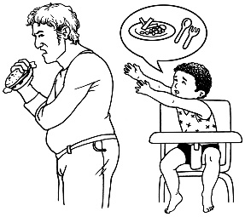
- emotional – a person yelling or saying things to you that are not nice
- neglect – a person not giving you the things or care you need.

The Royal Commission of Inquiry into Abuse in Care is also called the Commission.

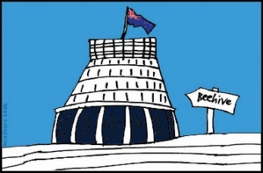
The Commission is not part of the Government.

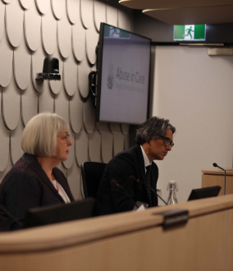
The Government cannot tell the Commission what to do.

The Commission is not part of any faith-based organisations like churches.

The Commission calls people who have been through abuse in care survivors.

What is the Crown Response Unit?

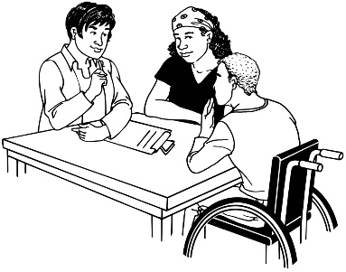
The Crown Response to the Royal Commission of Inquiry into Abuse in Care is a group of government officials that looks after the:
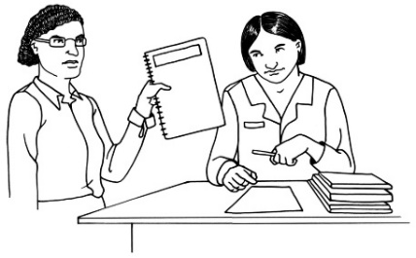
- contact between the Government and the Commission
- Government response to what the Commission finds out.

The response is what the Government will do because of what the Commission finds out.

What is the Redress Design Group?

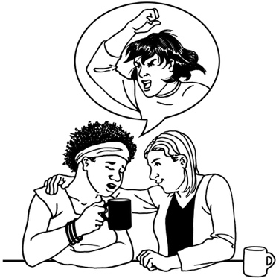
Redress means someone:
agrees that something bad has happened
does something to try to:
- put things right
- make up for any harm that has been done.

Redress can be things like:
saying sorry
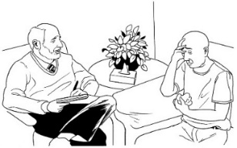
giving money as a way of saying sorry
giving other kinds of support like counselling.
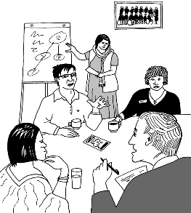
We are putting together some groups of people to work out the best ways of doing redress for survivors.

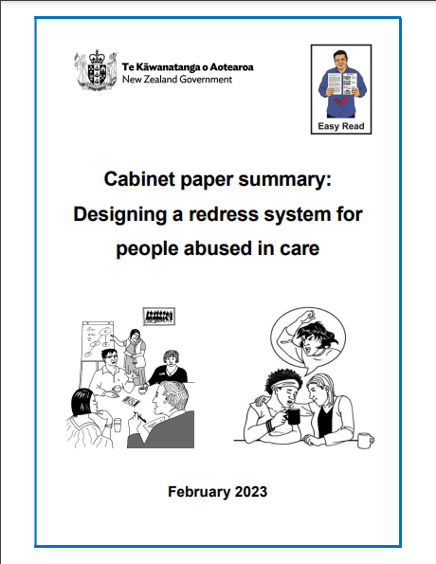
There is an Easy Read document with more information about this called:

Cabinet paper summary:
Designing a redress system for people abused in care

You can find this document at this website:
www.abuseinquiryresponse.govt.nz/
mo-matou-about-us/alternate-formats

About the 2 Co-chairs

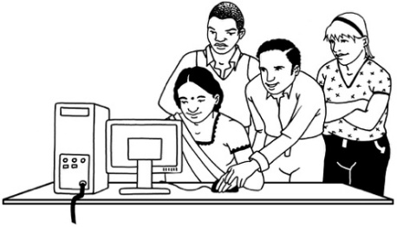
A lot of work needs to be done to make sure the redress system works well.

There is so much work to do that 2 people have been chosen to share the job of Chair of the Redress Design Group.

The job of the Chair is to make sure the redress system works well.

The job that the 2 people share will be called Co-chair.

They will work in this job for 7 months.
The 2 Co-chairs are:
- Annabel Ahuriri-Driscoll
- Ruth Jones.

About Annabel Ahuriri-Driscoll

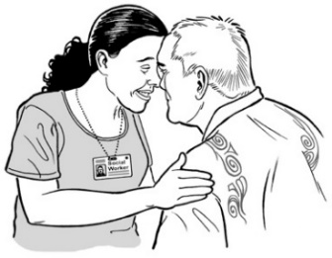
Annabel has done a lot of work to support Māori in healthcare.

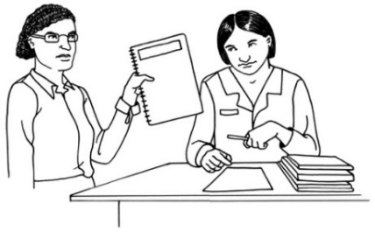
Annabel has a lot of experience of working in and writing about public health.

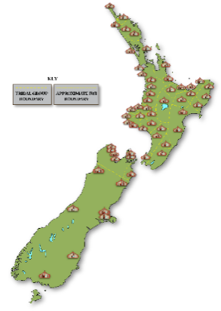
Annabel is from these iwi:
- Ngāti Porou
- Ngāti Raukawa
- Ngāti Kahungunu.
About Ruth Jones

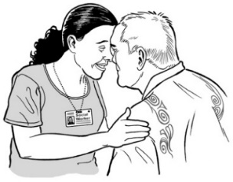
Ruth also has done a lot of work to support Māori in healthcare.

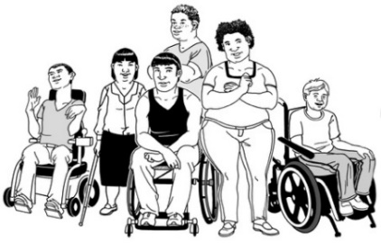
Ruth has a lot of experience working with groups that support disabled people.

She was given a medal from the Queen for some of the work she has done.

Ruth is from these iwi:
      - Ngāti Porou
- Rongowhakaata.

Ruth is also part of a board / group that gives advice to the Government about Oranga Tamariki.
Oranga Tamariki is the part of the Government that looks after children.

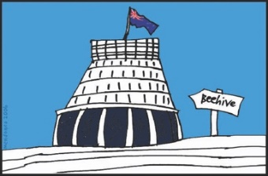
The board does not work for the Government.

Statement from the Co-chairs
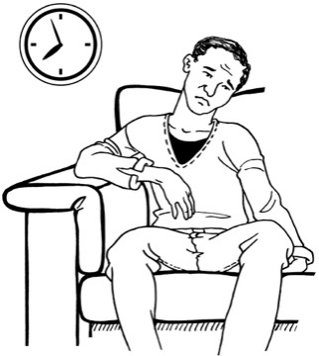

As Co-chairs we know that survivors have been waiting a very long time for redress.

We have both worked hard in all the jobs we have had to make sure we:
listen to survivors
speak up for survivors.

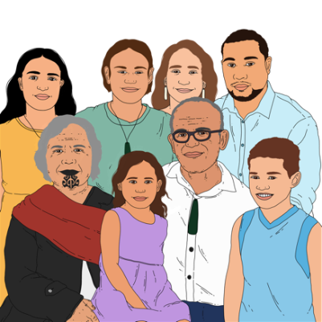
We also know how important it is to listen to survivors who are:
Māori
tāngata whaikaha /
Māori disabled people.

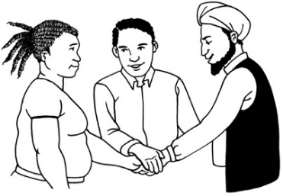
We understand:
how important this job is
how important it is for us to do this job right.

As Co-chairs we will work together to make sure all of what we do is:
guided by the voices of survivors
focused on what we have learned from listening to survivors.

We are working with the Crown Response Unit to put together a plan for how the redress system will work.

The people in the design group will meet up many times over 4 months to:
talk about what needs to happen
work with other advisory groups
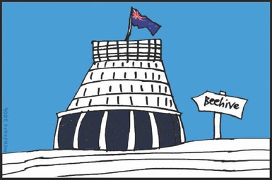
give recommendations about what needs to happen to the Government.
Recommendations are things we think should happen.

After these 4 months we will do more design work to make sure the things we have recommended get done.

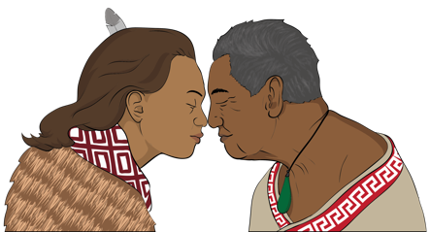
Our way of working will be guided by:
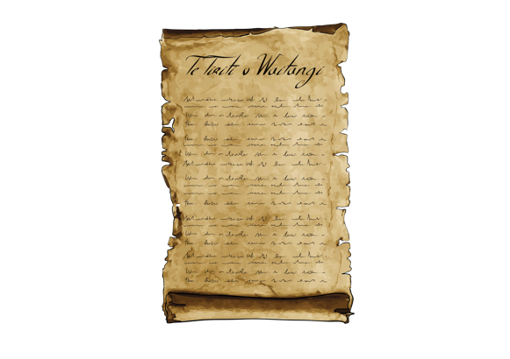
what is tika from a Māori way of thinking
the principles of Te Tiriti o Waitangi / Treaty of Waitangi.
Tika means something that is true / right.

Principles are like rules that tell people how to act / behave.

Te Tiriti o Waitangi / Treaty of
Waitangi is a legal document that
was signed in 1840.

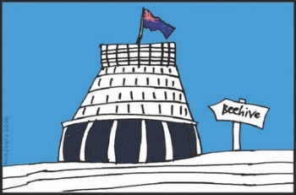
Te Tiriti o Waitangi / Treaty of Waitangi is about Māori and the New Zealand Government:
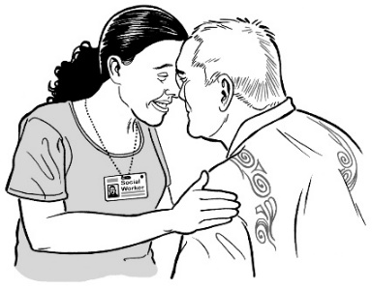
making decisions together
protecting things that are
important to Māori.

By working together like this we will make sure that what the redress system does is also tika.

Where to find more information

You can contact the Crown Response Unit about the new redress system:
by email at:

contact@abuseinquiryresponse.govt.nz
- by phone on:

04 815 6327

You can find more information about:
- the Crown Response Unit at:

www.abuseinquiryresponse.govt.nz
- the Royal Commission of Inquiry into Abuse in Care at:
www.abuseincare.org.nz
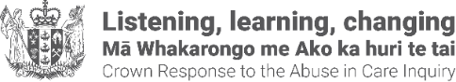
This information has been written by the Crown Response Unit.

It has been translated into Easy Read by the Make it Easy Kia Māmā Mai service of People First New Zealand Ngā Tāngata Tuatahi.

The ideas in this document are not the ideas of People First New Zealand Ngā Tāngata Tuatahi.

Make it Easy uses images from:

- Changepeople.org

- Photosymbols.com

- SGC Image Works

- Huriana Kopeke-Te Aho.
All images used in this Easy Read document are subject to copyright rules and cannot be used without permission.

