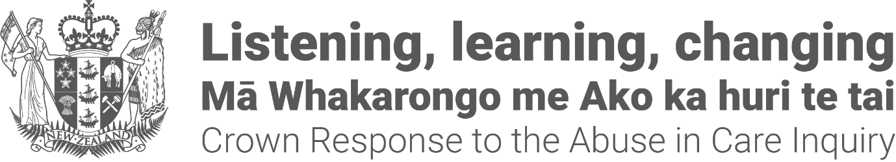

Crown Response to the Abuse in Care Inquiry:

Pānui / newsletter

April 2023

About this newsletter

This document is a newsletter from the Crown Response to the Royal Commission of Inquiry.

We will explain what the Crown Response to the Royal Commission of Inquiry is in the next parts of this document.
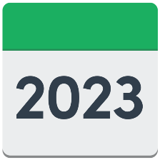
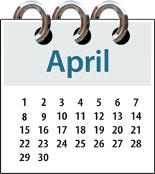

This newsletter is from April 2023.

You can find more newsletters from other months at this website:

www.abuseinquiryresponse.govt.nz/mo-matou-about-us/karere-news/
Some of the information in this document may upset people when they are reading it.

This information is not meant to upset anyone.

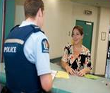
If you do not feel safe right now call the police on 111.

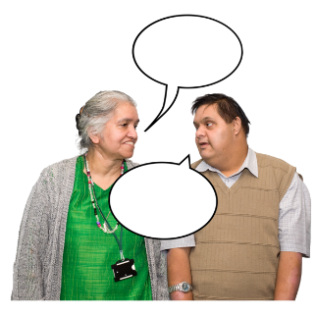
If you are worried or concerned after reading this you can talk about it with:
your family / friends
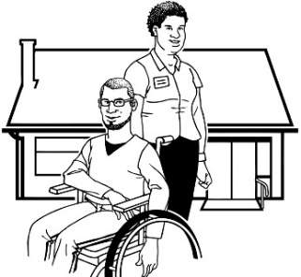
your support workers.

What is the Royal Commission of

Inquiry into Abuse in Care?

The Royal Commission of Inquiry into Abuse in Care is looking into abuse that happened to people
in care.

In this document being in care means that the government or a faith-based institution was in charge of your care.

Faith-based institutions are run by religious groups like churches.

Abuse can be:
- physical – a person kicking or hitting you
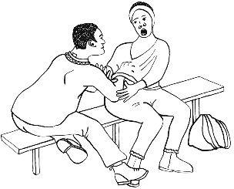
- sexual – when someone does sexual things to you that you do not want them to like:
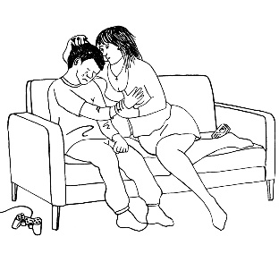
- touching your body or private parts
- kissing you
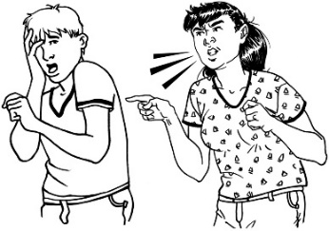
- making you have sex with them – this is called rape
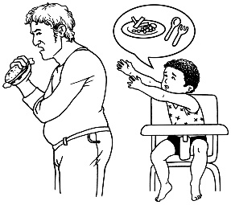
- emotional – a person yelling or saying things to you that are not nice
- neglect – a person not giving you the things or care you need.

The Royal Commission of Inquiry into Abuse in Care is also called the Commission.

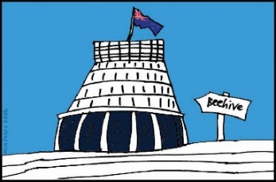
The Commission is not part of the Government.

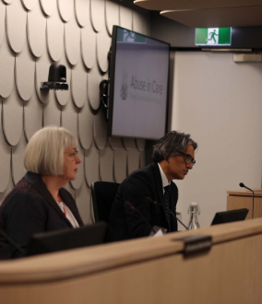
The Government cannot tell the Commission what to do.

The Commission is not part of any faith-based organisations like churches.

The Commission calls people who have been through abuse in care survivors.

What is the Crown Response Unit?

The Crown Response to the Royal Commission of Inquiry into Abuse in Care is sometimes called the:
- Crown Response Unit
- CRU.
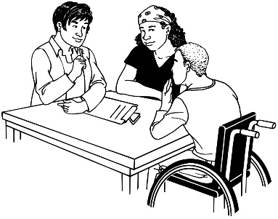

The CRU is a group of government officials that looks after the:
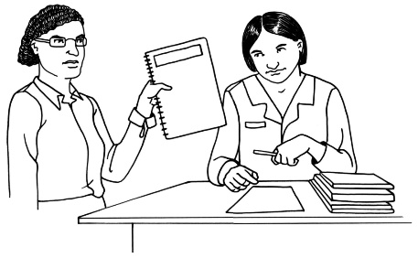
- contact between the Government and the Commission
- Government response to what the Commission finds out.

The response is what the Government will do because of what the Commission finds out.

Update on redress groups

Redress means someone:
agrees that something bad has happened
does something to try to:
- put things right
- make up for any harm that has been done.

Redress can be things like:
saying sorry
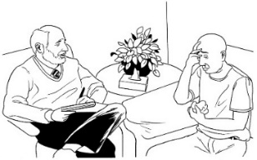
giving money as a way of saying sorry
giving other kinds of support like counselling.
We are putting together some groups of people to work out the best ways of doing redress for survivors.

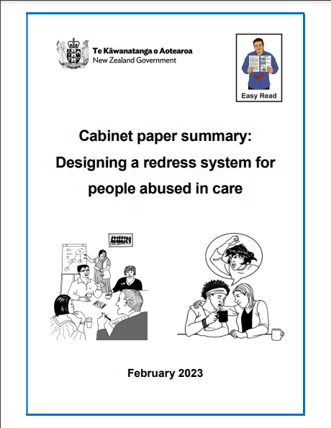
There is an Easy Read document with more information about this called:

Cabinet paper summary:
Designing a redress system for people abused in care.

You can find this document at this website:
www.abuseinquiryresponse.govt.nz/
mo-matou-about-us/alternate-formats

We are still working on finding the right people to work in the groups.
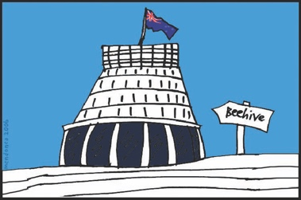
The Minister for the Public Service is the person in the Government who is responsible for the CRU.

The Minister for the Public Service is Andrew Little.

Andrew Little will decide who should be part of the groups.

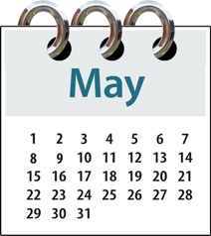
It is likely he will make his decision in May 2023.

New Co-chairs

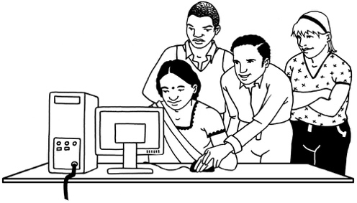
A lot of work needs to be done to make sure the redress system works well.

There is so much work to do that 2 people have been chosen to share the job of Chair.

The job of a Chair is to make sure the redress system works well.

The job that the 2 people share will be called Co-chair.

They will work in this job for 7 months.

The 2 Co-chairs are:
- Annabel Ahuriri-Driscoll
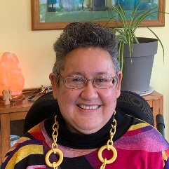
- Ruth Jones.

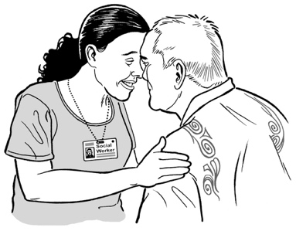
Annabel has done a lot of work to support Māori in healthcare.

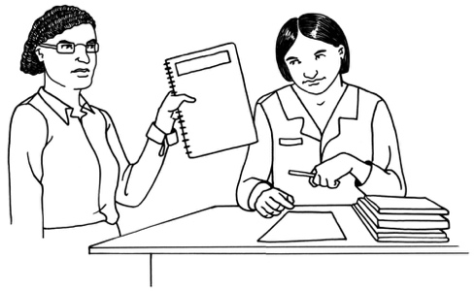
Annabel has a lot of experience of working in and writing about public health.

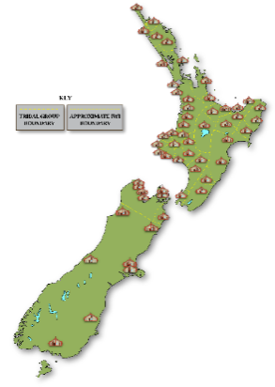
Annabel is from these iwi:
- Ngāti Porou
- Ngāti Raukawa
- Ngāti Kahungunu.

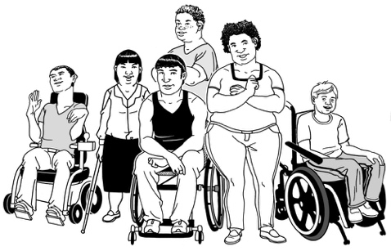
Ruth has a lot of experience working with groups that support disabled people.

She was given a medal from the Queen for some of the work she has done.

Ruth is from the Ngāti Porou and Rongowhakaata iwi.

Date of final report

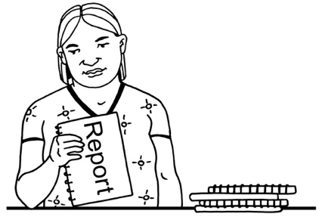
The Commission will write a final report to the Government about what they have found out about abuse in care.

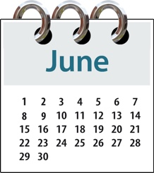
The date for the Commission to deliver this report was 30 June 2023.

The Government has agreed that the Commission can have 9 more months to write their final report.

This change is called a deferral.

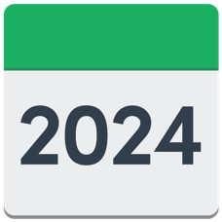
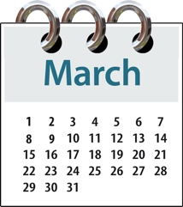
The Commission will now give their final report to the Government on 28 March 2024.
The person in charge of the Crown Response Unit is Isaac Carlson.

Isaac has promised that the deferral of the final report will not change how well the redress system works.

Rapid payments

Rapid payments are money that is given to survivors quickly as part of redress.

The Ministry of Social Development began offering rapid payments to survivors who have been waiting the longest.

Rapid payments have been given to survivors who are:
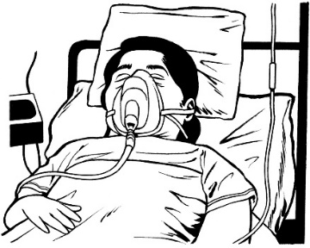
seventy years old or older
seriously ill.

The Ministry of Social Development says that survivors who have been given rapid payments think they work well.

Rapid payments will not be affected by the deferral of the final report.

You can find more information about rapid payments at:

https://bit.ly/3Aa3zLz
This information is not in Easy Read.

Listening service

The Listening service is a way survivors can share:
how they were abused
how being abused has affected them.

The listening service was part of the Royal Commission.

A new one will be set up by Government.
The Listening service will not be affected by the deferral of the final report.

National apology

Sorry
The CRU is working with the survivors on a public apology.

An apology is when you say sorry.

Public means for the whole country.

The public apology cannot be made until the Commission delivers their final report.

This means the public apology will likely happen in 2024.

Access to records for survivors
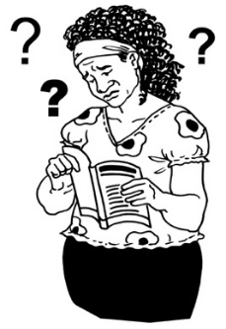

Many survivors have problems getting records of their time in care.

Records are things that were written or stored about them.

The CRU has been working on making the ways survivors can get their records better.
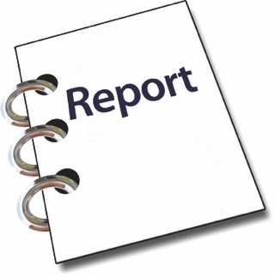

This work will not be affected by the deferral of the final report.

Where to find more information

You can contact the CRU about the new redress system:
by email at:

contact@abuseinquiryresponse.govt.nz

You can find more information about:
- the CRU at:

www.abuseinquiryresponse.govt.nz
- the Royal Commission of Inquiry into Abuse in Care at:
www.abuseincare.org.nz

This information has been written by the Crown Response Unit.

It has been translated into Easy Read by the Make it Easy Kia Māmā Mai service of People First New Zealand Ngā Tāngata Tuatahi.

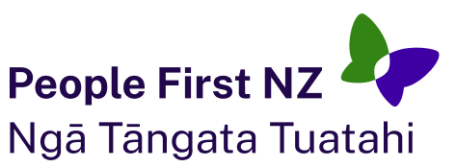
The ideas in this document are not the ideas of People First New Zealand Ngā Tāngata Tuatahi.

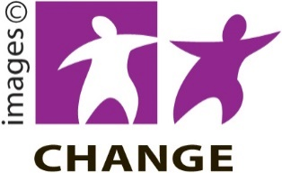
Make it Easy uses images from:

- Changepeople.org

- Photosymbols.com

- SGC Image Works

- Huriana Kopeke-Te Aho.
All images used in this Easy Read document are subject to copyright rules and cannot be used without permission.

