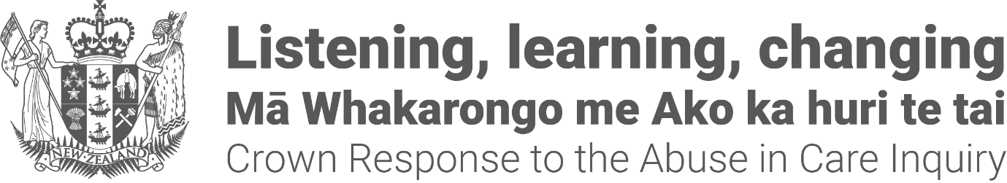

Crown Response to the
Abuse in Care Inquiry:
Pānui / Newsletter

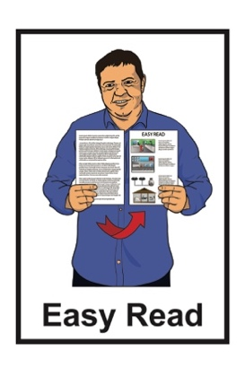
May 2023

About this pānui / newsletter

This Easy Read pānui / newsletter is from the Crown Response Unit called the CRU for short.

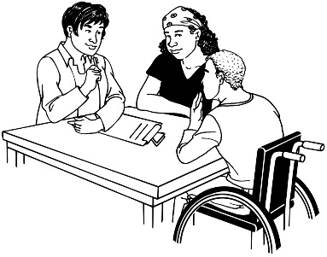
The CRU is a group of people who work for the government who look after:
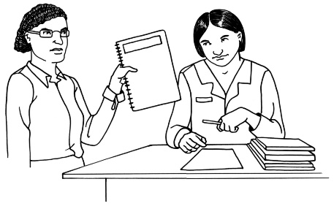
contact between the Government and the Royal Commission of Inquiry – Abuse in Care
the Government response to what the Royal Commission finds out.

The Royal Commission of Inquiry – Abuse in Care is explained in the on pages 5 to 7 of this document.

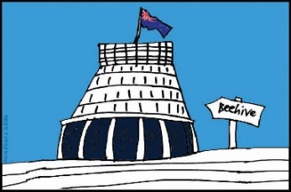
The response is what the Government will do because of what the Royal Commission finds out.

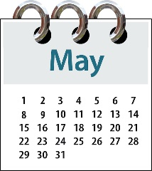
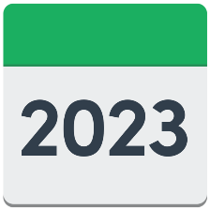
This Pānui / newsletter is from May 2023.

You can find more pānui / newsletters from other months at this website:

www.abuseinquiryresponse.govt.nz/mo-matou-about-us/karere-news/

Some of the information in this pānui / newsletter may upset people when they read it.

This information is not meant to upset anyone.

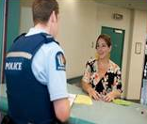
If you do not feel safe right now call the police on 111.

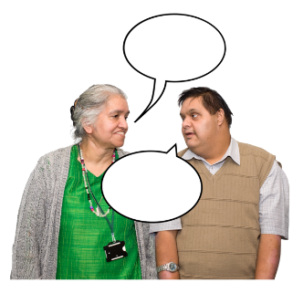
If you are worried or concerned after reading this you can talk about it with:
your family / friends
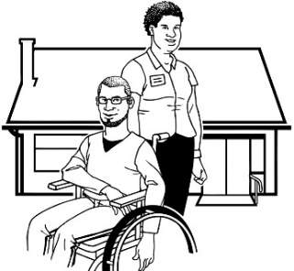
- your support workers.

What is the Royal Commission of Inquiry into Abuse in Care?

The Royal Commission of Inquiry into Abuse in Care is looking into abuse that happened to people
in care.

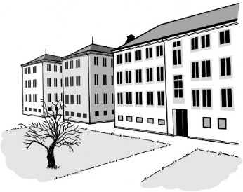
In this document being in care means that the Government or a faith-based institution were in charge of your care.

Faith-based institutions are run by religious groups like churches.

Abuse can be:

- physical – a person kicking or hitting you

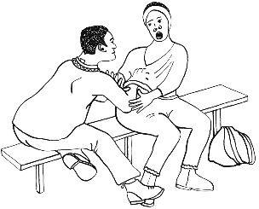
- sexual – when someone does sexual things to you that you do not want them to like:

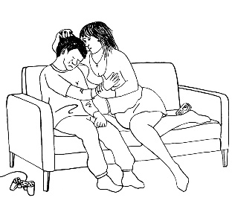
- touching your body or private parts

- kissing you

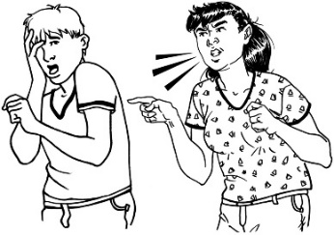
- making you have sex with them – this is called rape

- emotional – yelling or saying things to you that are not nice
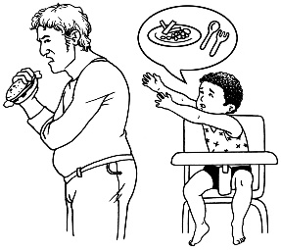
- neglect – not giving you the things or care you need.

The Royal Commission is not part of the Government.

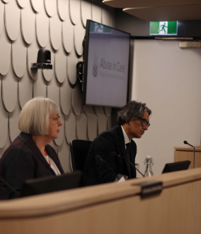
The Government cannot tell the Royal Commission what to do.

The Royal Commission is not part of any faith-based organisations like churches.

The Royal Commission calls people who have been through abuse in care survivors.

Update on Redress Groups

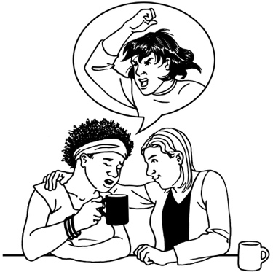
Redress means someone:
agrees that something bad has happened
does something to try to:
- put things right
- make up for any harm that has been done.

Redress can be things like:
saying sorry
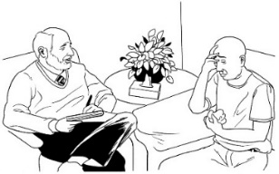
giving money as a way of saying sorry
giving other kinds of support like counselling.
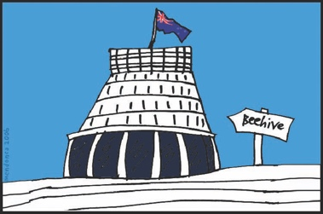
The Minister for the Public Service is the person in the Government who is responsible for the CRU.

The Minister for the Public Service is Andrew Little.

Andrew Little has chosen:
10 people to be in the Design Redress Group
16 people to be in the Advisory Redress Group.

You can read more about what these groups do on the Crown Response website:

https://tinyurl.com/CRUResources

Some of the information on this website is not in Easy Read.

Design Group Co-Chairs

The Minister for the Public Service chose 2 people to co-Chair the Design Group.

The job of the Chair is to lead the group to make sure redress works well.

When a group has 2 Chairs they are called co-Chairs.

The Design Group co-Chairs are:
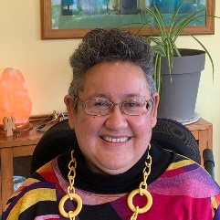
Dr Annabel Ahuriri-Driscoll
Ruth Jones.

Design Group members

The Design Group members are:
Dr Filipo Katavake-McGrath
Māhera Maihi
Tyrone Marks
Te Pare Meihana
Paora Moyle
Bernie O’Donnell
Dr Michael Roguski
Tupua Urlich
Keith Wiffin
Dr Steve Winter.

Advisory Group members

The Advisory Group members are:
Kararaina Beckett
David Crichton
Dr Alison Green
Joanna Ilolahia
Toni Jarvis
Bianca Johanson
Denise Messiter
Heidi Nayak.

There are more names of Advisory Group members on the next page.

More Advisory Group members are:
Sevia Nua
Fleur Ramsay
Paora Sweeney
Frances Tagaloa
Jacinda Thompson
Jenni Tupu
Emma West
Matthew Whiting.

Rapid Payments

Rapid Payments is money that is given to survivors more quickly as part of redress.

The Government has made more money available to help the Ministry of Social Development carry on with redress.

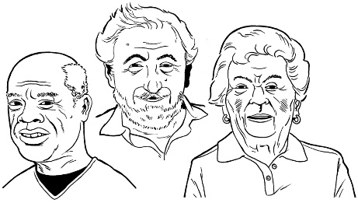
The Ministry is still making rapid payments to survivors who are
old / ill.

The Ministry is starting to work on redress for survivors cared for by a government agency called Child, Youth and Family in the past.

This includes redress for survivors from when Child, Youth and Family had other names.

Child, Youth and Family is called Oranga Tamariki now.

More information about Rapid Payments

You can download a fact sheet to get more information about Rapid Payments:

https://tinyurl.com/muxyufz9

The information is not in Easy Read.

You can also phone the Ministry of Social Development for more information about Rapid Payments:

Phone: 0800 631 127

This phone call will not cost you any money.

You can also use the New Zealand Relay Service to call the Ministry of Social Development if you are:
- Deaf / hearing impaired
- deafblind
- find it hard to speak.

You can find more information about the New Zealand Relay Service on their website at:

https://www.nzrelay.co.nz

Survivor Experience Service

From July 2023 a new Survivor Experience Service will give survivors a different way to share what happened to them.

This service will replace the Abuse in Care Royal Commission of Inquiry:
new survivor registration service
private sessions services.

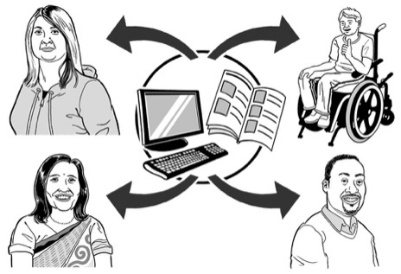
The CRU will tell everyone more about the new Survivor Experience Service soon.

Access to records for survivors

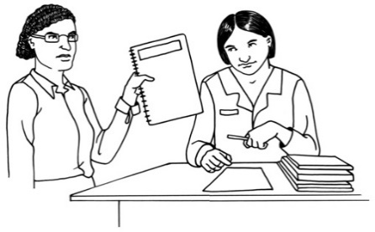
Records are things that people write down about another person.

Sometimes records have parts covered up or taken out so that no one can read them.

Some records have more information covered up or taken out than others.

The Abuse in Care Royal Commission of Inquiry redress report said this was not good enough.

To help agencies to know what to do the CRU has made new guidelines for agencies.

The guidelines are called Shared Redaction Guidance.

Redaction means putting a black line over something in a record so that no one can read it.

The Shared Redaction Guidance says what things agencies:
may take out of a record
must not take out of a record.

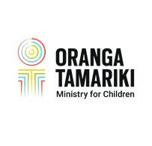
The agencies in the following list say they will use the Shared Redaction Guidance:
Oranga Tamariki
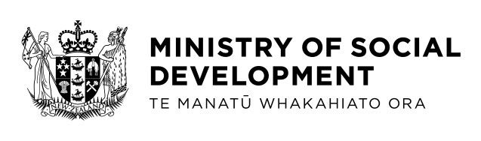
Ministry of Social Development – Historic Claims Unit
Ministry of Education – Sensitive Claims
Ministry of Health
Whaikaha – Ministry of Disabled People
Methodist Church Archives of New Zealand.

There is Easy Read information about the Shared Redaction Guidance on the Crown Response website here:

www.abuseinquiryresponse.govt.nz/mo-matou-about-us/alternate-formats/

Funding update

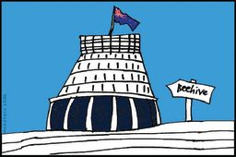
The Government has made money available for redress work.

You can find out more about how much money there is for different parts of the work on the CRU website:

https://tinyurl.com/CRUfunding

The information is not in Easy Read.

Where to find more information

If you want to contact CRU about the new redress system you can:
send an email to:

contact@abuseinquiryresponse.govt.nz

You can find more information about the:
- CRU on their website at:

www.abuseinquiryresponse.govt.nz

- Royal Commission of Inquiry into Abuse in Care on their website at:

www.abuseincare.org.nz

This information has been written by the Crown Response Unit.

It has been translated into Easy Read by the Make it Easy Kia Māmā Mai service of People First New Zealand Ngā Tāngata Tuatahi.

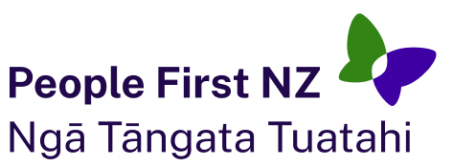
The ideas in this document are not the ideas of People First New Zealand Ngā Tāngata Tuatahi.

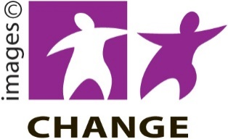
Make it Easy uses images from:

- Changepeople.org

- Photosymbols.com

- SGC Image Works

- Huriana Kopeke-Te Aho.
All images used in this Easy Read document are subject to copyright rules and cannot be used without permission.

